“First Invasion: War of 1812”
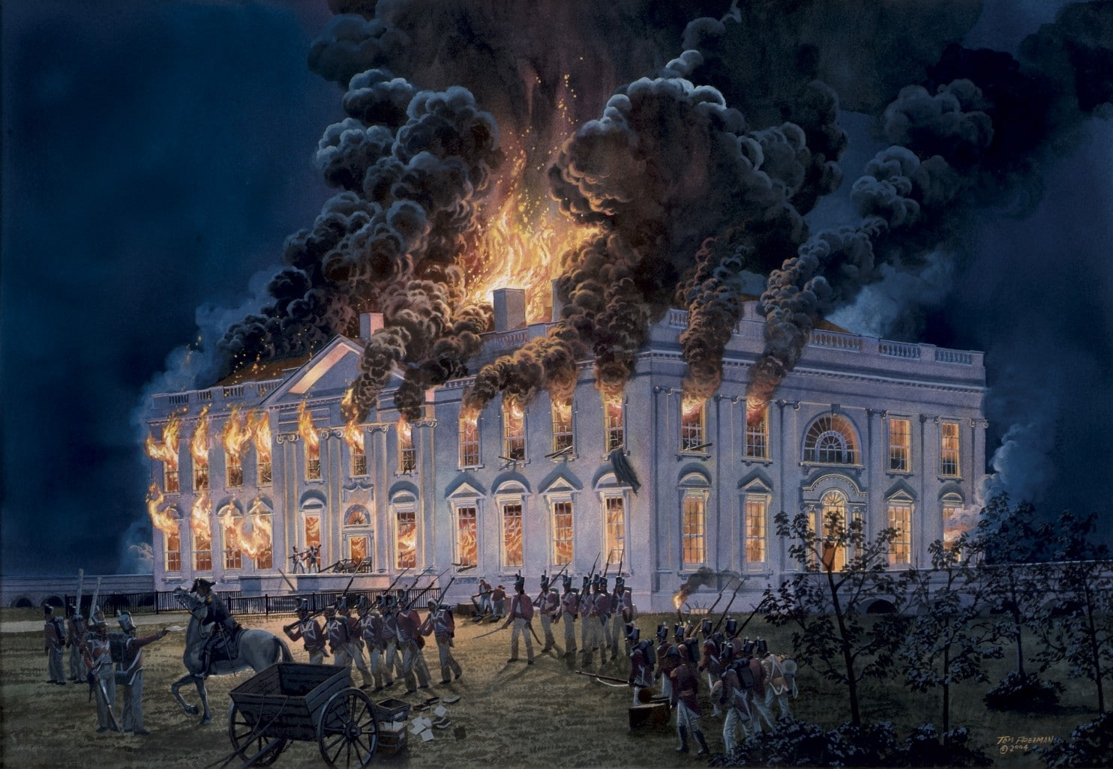
- Identify and explain the main issues leading to the declaration of war in 1812. What is ironic about the causes of the War of 1812?

- Explain impressment and why it became such an issue between the U.S. and Great Britain.

- Explain why New England Federalists opposed the war and how Federalist opposition played into later events in the war.

- Explain several ways the U.S. military was unprepared for war as they took on the British in Canada.

- How did Dolly Madison and Stephen Pleasanton help “save” the nation’s history?

- Describe the contributions women made to the War of 1812.

- Explain why the death of Robert Ross was such a critical loss for the British.

- Explain what the flag symbolized to Francis Scott Key as it flew at Fort McHenry.

- What miscommunication led to the continuation of the war to New Orleans?

- Explain the methods General Andrew Jackson used to fortify New Orleans for British attack.

- Explain the long-term consequences of the war for the U.S. and for Great Britain.

- Why has the War of 1812 been referred to as “America’s Forgotten War”?

