Unit 5 Essential Terms and Questions
Essential Terms
Out of the terms below, identify and explain their significance in American History. Honors will need to complete 20, and Academic needs to complete 15. Be deliberate in your choice of the terms, there will be some that you feel you do not need to review before the assessment. Remember, if a term is more general in nature, be sure to explain it as it pertains to American History.
Typically, for identification, ask yourself the "who was involved, what happened, what other essential term is it related to and why, where did it take place, etc." For significance, ask yourself "why is this important for the course, what is the outcome, what does it lead to, etc." - choose terms that you truly need to review again, not ones you already know. Please underline your significance. *Terms for 5A are in brackets below*
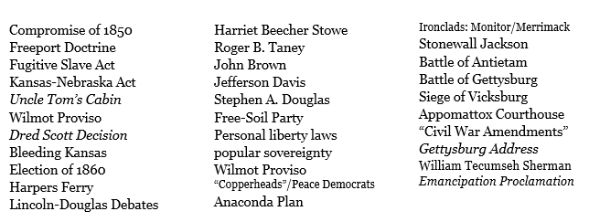

Essential Questions
Answer the following questions in 3-5 complete sentences. Any plagiarized material will not be accepted. Academic students may pick any 3 to answer; Honors students must answer 5 questions. Try to use as many of your vocabulary words in your answer as possible.
- Why did Buchanan fail at preventing civil war? *only 5A question*
- What were the advantages and disadvantages of Union versus the CSA?
- What Constitutional liberties was Lincoln willing to sacrifice to “preserve the union”?
- What were the strategies of the Union versus the CSA?
- What are the effects of “total war”?
- How did the Civil War change daily life?
- How did women and minorities contribute in the Civil War?
- What are the lasting impacts of the Civil War?

