The Texas War for Independence
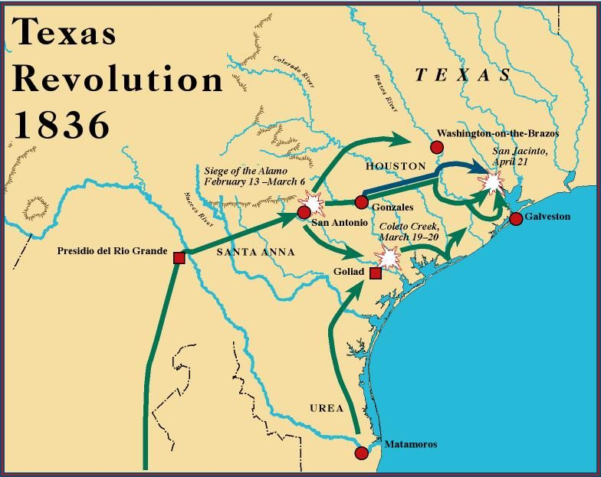
Directions: be sure to annotate your notes as you watch the video and complete the following tasks.
1. Explain the causes of the Texas War for Independence.

2. What political changes occurred before, during, and after the TX War for Independence?
Before:

During:

After:
3. List and explain the impacts of the Texas Revolution.

Reshaping the Nation: The Mexican American War Viewing Guide
- Who was “Old Rough and Ready”? Why was he “relieved” of command by Polk?

- How did Polk “provoke” Mexican troops into starting the war?

- What caused the most American casualties in Mexico?

- How was the taking of California different than that of Santa Fe?

- Explain what was lucky about the timing of the Treaty of Guadalupe Hidalgo.

- Why do historians suggest that so little attention is given to this war in American History?

Identify and explain the significance of the following people in the Mexican American War:
Ulysses S. Grant and  Robert E. Lee | John Slidell | James K. Polk
Antonio Lopez de Santa Anna | Nicholas Trist | Stephen Kearney

