PBS’ American Experience: The Triangle Shirtwaist Fire
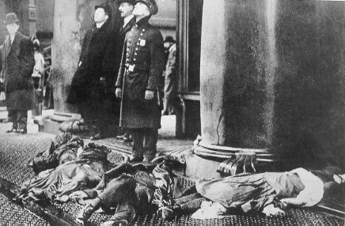
PBS’ American Experience: Triangle Fire provides an account of a sensational moment in labor history and in the evolution of American ideas regarding government. It will begin with the conditions in the factory for women, their fight as a union to improve their workplace, and the tragic fire that occurs as a result of owner negligence. After viewing the video, answer the following questions thoughtfully and completely.
The film can be found on my website www.leininger.weebly.com. PBS often removes their videos from YouTube, so if it is not available, there are other ways to access it that we can discuss. You may also do a search for PBS American Experience - Triangle Fire, there is a transcript of the video on the site if you find that useful.
The Immigrant Experience
- According the film what countries of origin were represented among the garment workers?
- What brought these immigrants to America?
- How did the realities of their working lives contrast with their dreams and their observations of opportunity in America?
- What did Blanck and Harris have in common with the women who worked for them at the Triangle Shirtwaist Factory?
- How did their stories embody the “American Dream”? Why were they “lionized” (glorified)?
Working Conditions
- What was a typical day like for workers at the factory? In what ways was the workplace dangerous?
- How much money did they earn? What account from the worker about factory life struck you as the most troubling?
- Why were Harris and Blanck brought up on charges of manslaughter? What was the outcome of this case?
The Legacy
- What impact did the Triangle fire have on the private system of unregulated industry?
- What concrete changes were made to make workplaces safer for factory workers?

