The American Experience
The Triangle Shirtwaist Fire
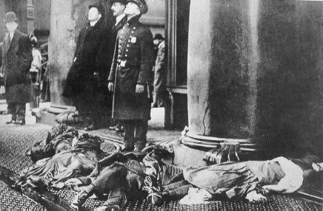
PBS’ American Experience: Triangle Fire is a fifty minute video which provides an account of a sensational moment in labor history and in the evolution of American ideas regarding government. It will begin with the conditions in the factory for women, their fight as a union to improve their workplace, and the tragic fire that occurs as a result of owner negligence. After viewing the video answer the following questions thoughtfully and completely. This will count as two classwork grades.
The film can be found on my website www.leininger.weebly.com. You may also do a search for PBS American Experience - Triangle Fire, there is a transcript of the video on the site if you find that useful.
The Immigrant Experience
- According the film what countries of origin were represented among the garment workers? What brought these immigrants to America? How did the realities of their working lives contrast with their dreams and their observations of opportunity in America?
- What did Blanck and Harris have in common with the women who worked for them at the Triangle Shirtwaist Factory? How did their stories embody the American Dream? Why were they “lionized” (glorified)?
Working Conditions
- What was a typical day like for workers at the factory? In what ways was the workplace dangerous? How much money did they earn? What anecdotes about factory life strake you as the most troubling?
- How many people died in the fire? Why were Harris and Blanck brought up on charges of manslaughter? What was the outcome of this case?
The Legacy
- What impact did the Triangle fire have on the private system of unregulated industry? What concrete changes were made to make workplaces safer for factory workers?

The American Experience
The Triangle Shirtwaist Fire
PBS’ American Experience: Triangle Fire is a fifty minute video which provides an account of a sensational moment in labor history and in the evolution of American ideas regarding government. It will begin with the conditions in the factory for women, their fight as a union to improve their workplace, and the tragic fire that occurs as a result of owner negligence. After viewing the video answer the following questions thoughtfully and completely. This will count as two classwork grades.
The film can be found on my website www.leininger.weebly.com. You may also do a search for PBS American Experience - Triangle Fire, there is a transcript of the video on the site if you find that useful.
The Immigrant Experience
- According the film what countries of origin were represented among the garment workers? What brought these immigrants to America? How did the realities of their working lives contrast with their dreams and their observations of opportunity in America?
- What did Blanck and Harris have in common with the women who worked for them at the Triangle Shirtwaist Factory? How did their stories embody the American Dream? Why were they “lionized” (glorified)?
Working Conditions
- What was a typical day like for workers at the factory? In what ways was the workplace dangerous? How much money did they earn? What anecdotes about factory life strake you as the most troubling?
- How many people died in the fire? Why were Harris and Blanck brought up on charges of manslaughter? What was the outcome of this case?
The Legacy
- What impact did the Triangle fire have on the private system of unregulated industry? What concrete changes were made to make workplaces safer for factory workers?

