The Century: America’s Time –
Starting Over: 1976-1980
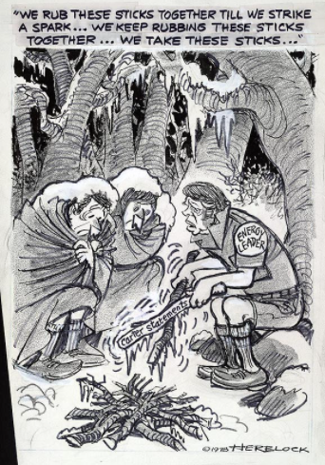
1. Explain why Americans were “unsure” of themselves in 1976.
2. Explain what Jimmy Carter represented to many Americans. Why weren’t young people interested in politics?
3. Explain the impact the women’s rights movement had on marriages and families. How was this considered “unorthodox”?
4. What impact did the cold weather in 1977 have on the U.S. and our energy sources?
5. Explain the impact foreign competition had on the auto industry and the American worker.
6. Explain what happened to “Love Canal”. How did the people living there remedy the problem?
7. How was forced busing received by citizens in America? How did it impact schools?
8. What happened in San Francisco that galvanized the gay community to stand together?
9. Why were conservatives concerned that America was morally disintegrating by the late 1970s?
10. Explain the events that took place in Iran in 1979. Why were the Ayatollah Khomeini’s ideas so extreme?
11. Why was the U.S. hockey team’s victory in the 1980 Olympics so important for America?
12. Who was Ronald Reagan and why was he so appealing to Americans?

