Lee Daniels’: The Butler
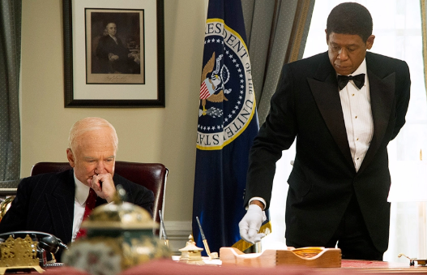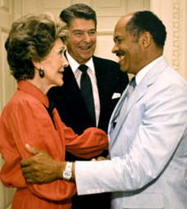

The “Fiction & Purpose” of Cecil Gaines | The “Historic Truths” of Eugene Allen

Lee Daniels’: The Butler

The “Fiction & Purpose” of Cecil Gaines | The “Historic Truths” of Eugene Allen
-VA plantation  -No rape or shooting; done to “create the fear that builds subservience into Cecil’s DNA”  -“This is not the Eugene Allen story. It’s not just about him. We were hoping to capture the essence of Allen, and I think we did…it’s about several other people I spoke to that worked at the White House as well so that the film would create this universal truth for many people of what that experience was like.”  -Son did go to Vietnam, but did not die – instead became an investigator with the State Dept.  -No eldest son who was a Freedom Rider and Black Panther (“the rift that develops between generations”)  -Wife Helene not an alcoholic or contemplated an affair (done perhaps for Winfrey)  -“Moment” at the state dinner where he realizes he’s been “wearing a mask over the years to cover up his subservient job” (Eugene actually had champagne that night, which he grinned about because he was the one who stacked the WH champagne) | -Met a connection to the White House when he wasn’t looking for a job (incorrect quote of “The White House call him, he didn’t call the White House”)  -Promoted to maître d’ by Reagan in ‘80  -Jackie left the suit on deliberately for the inauguration of LBJ (said to Lady Bird, “oh no…I want them to see what they have done to Jack.”)  -Personal invite to JFK’s funeral, stayed to serve everyone after they came from the funeral  -Yes Jackie gave tie to Eugene (he said “Jack Kennedy was very nice and so was Mrs. Kennedy”)  -True, Reagan did not impose sanctions for apartheid for diplomatic reasons rather than the way it was portrayed (South Africa was the only country that held a strong anti-communist position and the sanctions would have impacted the least affluent in the country first, who were mainly blacks)  -Nancy Reagan personally invited him to a state dinner (after selecting the China, she told him he’d be attending, not working)  -Wil Haygood believed Obama would win in 2008, so he thought it would be a great interview  -Helene died the day before Obama won the election in 2008  -“Placed his vote” and attended the inauguration with Charles, his daughter in law, and Haygood (it was the only inauguration he ever attended)

