America: The Story of Us – “Bust”
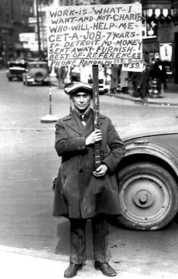
Answer the following questions on a separate sheet of paper.
- The 1920s were boom time. In 1929, more money was spent on _____________________ than education.
- In an age of consumerism and capitalism over $___billion goods are bought on credit
- ___% of Americans had no savings.
- In October 1929, the stock market loses _____ times more money in three weeks than the government spends in a year.
- Only the ___% of Americans who owned stock were immediately affected by the stock market. The rest of them got on with their lives until the Bank of the U.S collapsed.
- In the last 60 days of 1930, over _________(#) of banks closed nationwide. By 1933, there were ____ states without banks.
- Unemployment in the United States went from ___ million 1930 to ___ million in 1932. Every day __________________ homes are repossessed.
- Hoover Dam, a public works project, provided employment for _____ men. It will provide water and electricity for the American southwest.
- Hoover Dam creates the largest water reservoir in the U.S., Lake ________ and allows _____________ to produce more food than any other state in the U.S.
- One side-effect of the Hoover Dam was that ________________________________________, a tiny nearby town of 5,000 boomed as construction workers traveled for parties and gambling. Today over _____ million people travel there every year.
- Describe “The Dust Bowl”.
- In 1936, U.S. farmers were losing $____million per day.
- 250,000 people flee the Dust Bowl; however, _____ (fraction) stick it out.
- How did the radio transform America in the 1930s?
- Mount Rushmore was built as part of President Franklin Delano Roosevelt’s government program called the ________ Deal.
- Despite the public works programs, in 1936 1 in ___ Americans were still unemployed.
- What event would it take to get the United States out the Great Depression? ______________
- In 1936, African-American Joe Lewis would face off against German Max Schmeling for boxing’s heavy weight title. ____ million Americans would listen to the fight on the radio. Joe Lewis was the hope of African-Americas, about _____% of which were unemployed.
- ___________________________________ was the winner of the 1936 Heavyweight Title.
- The rematch between Schmeling and Lewis was scheduled for June 22, 1938 at Yankee Stadium in New York. This fight would pit good vs. evil; democracy vs. __________________. ______ million Americans would listen to the fight, 100 million worldwide.
- Joe Lewis won the rematch in only ______ seconds. The second quickest heavyweight title fight in history.
- What was the symbolism of the Lewis/ Schmeling fight?

