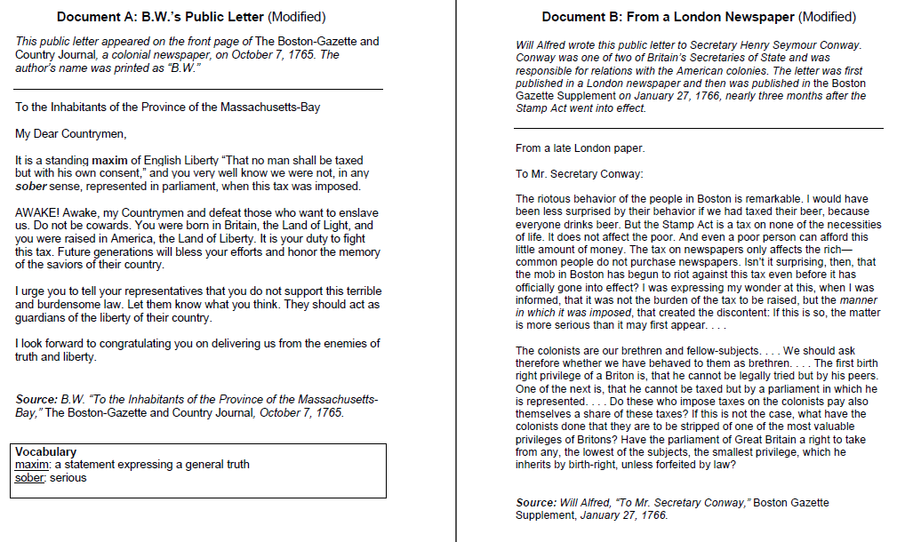

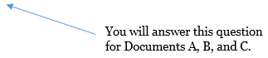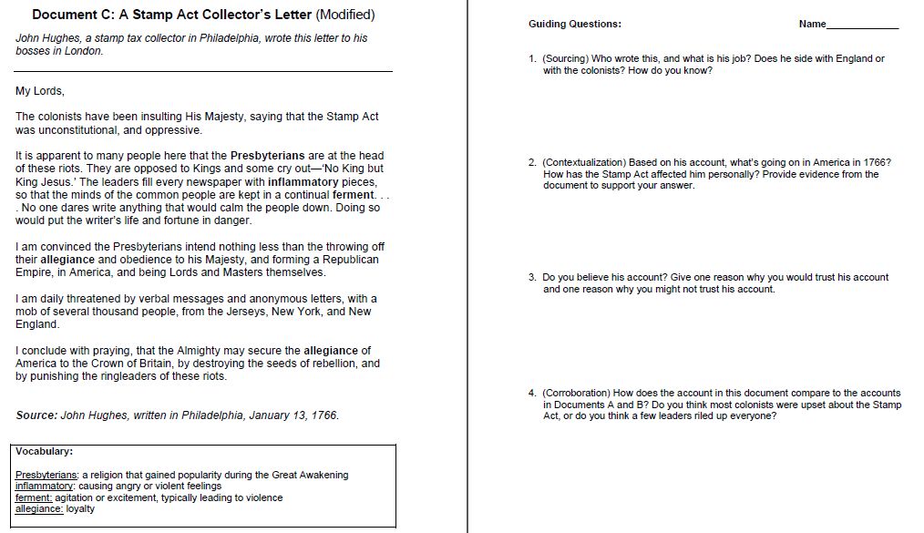

You’re comparing Document C to the accounts in Documents A and B.

You will answer this question for Documents A, B, and C.