Sources on the “Peculiar Institution” of Slavery

Source #1: Crops, Livestock, and Populations

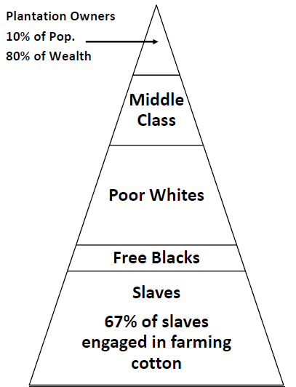
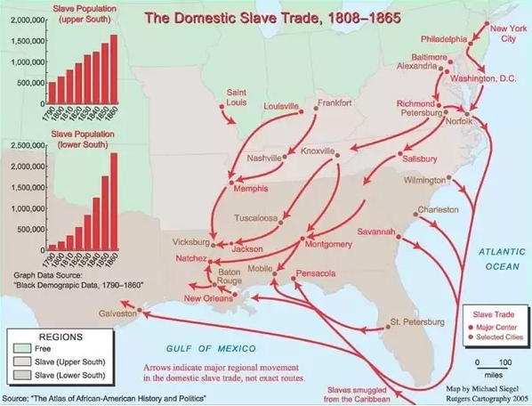
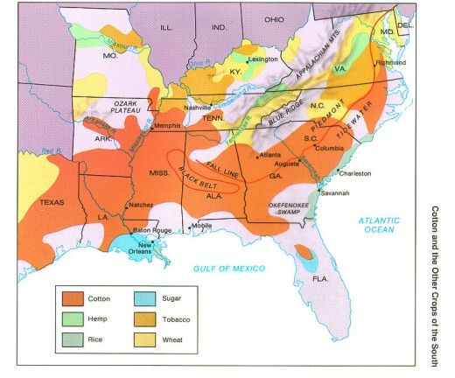

Source #2: Slave Codes and Manumission

The United States Constitution never even uses the words slavery or slave yet this “peculiar institution” was a vital piece of the nation’s economy and the South’s culture. Instead of federal laws, each southern state had its own laws, or slave codes, restricting blacks’ rights and freedoms. These laws prohibited everything from learning to read to holding office to interracial marriages. They even restrict the movement of free slaves and limit the conditions under which slaves can be manumitted. Manumission is the act of freeing, or emancipating, an individual slave. Some masters manumitted their slaves for good behavior or long service. Other slaves bought their own freedom – sometimes being forced to leave the state because they were suddenly excluded as a free black.

Southern states weren’t the only ones to place restrictions on blacks. Northern states maintained their own black codes.

Look over the list of laws and restrictions to answer the questions.

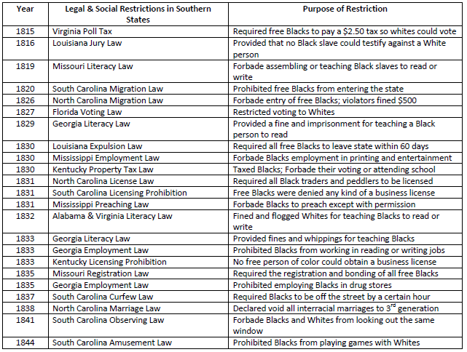

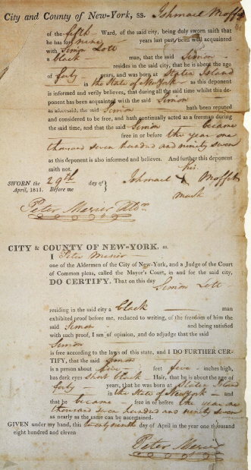

Source #3: The International and National Slave Trade

The Atlantic Slave Trade took at least 12 million people from the African continent. There was already a slave trade within the continent of Africa. Slaves in Africa were often prisoners of war and they or their children were freed after a number of years. Many tribal leaders participated in the slave trade, fighting wars to capture slaves to sell to traders on the coast. Slaves were kept in the dungeons of coastal forts and then loaded onto boats to cross the Atlantic. But New World slavery was vastly different from the slavery in Africa. Even the journey took its toll. An estimated one to two million enslaved Africans died en route. Far more slaves actually went to South America and the Caribbean than to the United States. Brazil alone imported four million slaves.

Once slaves arrived in the New World, they were auctioned off to the highest bidders – Planters or traders. Slaves were also sold at auction or to traders when masters were moving or needed money, or as punishment. At the height of the internal slave trade, around 1850, a healthy young man could sell for as much as $1,000 to $2,000, the equivalent of $15,000 to $40,000 by today’s currency standards. The international slave trade was outlawed in 1808, but smugglers still brought new Africans in via the Caribbean, and within the country trade flourished, especially as cotton demanded more and more laborers in the Deep South.

Look over the documents and drawings to answer the questions.

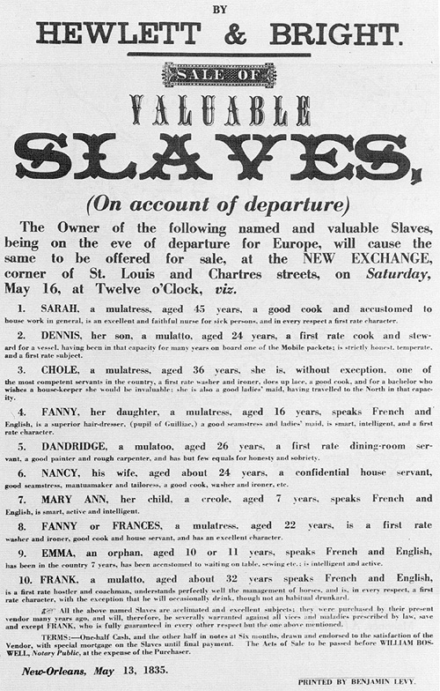

Source #4: Slave Narratives

Slave Voices: Life as a slave varied, depending on the owner and the type of work required. Here are some slaves’ own words about their lives.

Madison Bruin, former slave
Ole Marster was good to us. He give us plenty of good food. I git plenty of whippin’s, but he never beat us hard…Ole Marster, he beat me and his son just the same.

Betty Powers, former slave
All the rations are measured out on Sunday morning…’Twarn’t enough for the heavy eaters…The short rations caused lots of trouble, ‘cause the blacks have to steal food. ‘Twas a whipping if they get caught. The colored folks are in a hell of a fix if they can’t do the work ‘cause they’re weak (from hunger). ‘Twas a whipping then for sure.

Hilliard Yellerday, former slave
When a girl became a woman, she was required to go fo a man and become a mother. There was generally a form of marriage. The master read a paper to tell them telling them they were man and wife. Some were married by the master laying down a broom and the two slaves, man and woman, would jump over it. The master would then tell them they were man and wife, and they could go to bed together.

Mary Gaffney, former slave
When a slave died, we just dug a hole in the ground, built a fence around it, and piled him in. No singing, no preaching or praying, ever took place during slavery time. Master would say, “Well, he was a pretty good Negro. Guess he will go to Heaven, all right.” And that was about all there was to a Negro funeral, then. We would not even shed a tear, because he was gone where there would not be any more slaves. That was all the slave thought about, then – not being a slave. Because slavery time was hell.

Rachel Cruze, former slave
I was born on the farm of Major William Holden…My father was William Holden, Jr., the youngest child of Major Holden. My mother, Eliza Mobley, was the colored cook…I lived in Old Major’s house as a member of the family all those years.

Jacob Manson, former slave
We worked all day an’ some of the nights an’ a slave who make a week, even after doin’ that, was lucky if he got off without getting’ a beatin’. We had poor food, and the young slaves was fed out of troughs….The children were looked after by the old slave women who were unable to work in the fields, while the mothers of the babies worked. The women plowed and did other work as the men did. No books or learning of any kind was allowed.

Emily Dixon, former slave
On Sundays, we would git together in the woods an’ have worship. We could go to the white folks’ church, but we wanted to go where we could sing all the way through, an’ hum along, an’ shout – you all know; just turn loose like.

Mary Reynolds, former slave
Solomon the overseer beat [the slaves] with a big whip and Massa look on. The blacks better not stop in the fields when they hear them [the slaves being beaten] yellin’. They cut the flesh ‘most to the bones, and some they was, when they taken them out of stock and put them on the beds, they never got up again.

Florence Napier, former slave
I sure enjoyed myself on the old plantation, and we-uns all had a good time. Always have plenty to eat. Master used to say, “The colored folks raised the food, an’ they’s entitled to all they wants.” Same with the clothes.

Josiah Henson, former slave
Common as are slave-auctions in the southern states, and naturally as a slave may look forward to the time when he will be put up on the block, still the full misery of the event…is never understood till the actual experience comes…My [five] brothers and sisters were bid off first, and one by one, while my mother, paralyzed by grief, held me by the hand…Then I was offered to assembled purchasers…I must have been then between five and six years old. I seem to see and hear my poor weeping mother now.

Source #5: Resistance

Sometimes slaves revolted violently. Many tried to escape. Most common, though, was passive resistance – small acts that white slave owners and overseers might not catch on to. Here are some examples of passive resistance.

Rachel Cruze, Tennessee slave
Old Henry never ceased groaning and holding his side…Dr. Sneed finally arrived and examined Henry thoroughly. Then he gravely ordered some medicine to be given regularly, with complete rest…The doctor leaned over and whispered, “Julia, there is not a damn thing the matter with Henry.”

Anonymous female slave
“Don’t say I’m wicked [for stealing]…It’s all right for us poor colored people to appropriate whatever of the white folks’ blessings the Lord puts in our way.”

Anonymous female slave
“Old Mistress got sick, and I would fan her with a brush, to keep the flies off her. I would hit her all in the face. Sometimes I would make out I was asleep and beat her in the face.”

Spirituals as Songs of Resistance

Deep River  My home is over Jordan, yes My Deep River, lord. I want to cross over into campground  Wade in the Water  Wade in the water, Wade in the water Children Wade in the water, God’s gonna trouble the water.  Steal Away  Steal away, steal away Steal away, to Jesus! Steal away, steal away home, I ain’t got long to stay here.  Many Thousand Gone  No more auction block for me. No more, no more, No more auction block for me Many thousand gone. | Heav’n Boun’ Soldier  Hold out yo’ light, you heav’n boun’ soldier Hold out yo light, you heav’n boun’ soldier Let yo’ light shine a roun’ de world  Follow the Drinking Gourd  Follow the drinking gourd! Follow the drinking gourd, For the old man is awaiting for to carry you to freedom If you follow the drinking gourd.  When the sun comes back and the first quail calls, Follow the drinking gourd, For the old man is awaiting to carry you to freedom If you follow the drinking gourd.  The riverbank makes a very good road, The dead trees will show you the way, Left foot, peg foot travelling on, Follow the drinking gourd.  Swing Low, Sweet Chariot  Swing low sweet chariot, comin’ for to carry me home I looked over Jordan and what did I see, Comin’ for to carry me home A band of angels comin’ after me, Comin’ for to carry me home

Runaway Ads – New Bern, N.C.

August 5, 1797

RUN-AWAY from the subscriber about 8 days past, a negro fellow about twenty five years of age: he is short, well set, and active; not very black, and works very well at the Blacksmith’s trade. This fellow was raised in Newbern, and formerly belonged to Abner Nash, Esq. – It is supposed he has gone to Newbern to get on board some vessel – He has two brothers, ABRAM and TOM, who live in Newbern, and who, I suppose will keep him secreted until he can get off. If this fellow is not yet got to Newbern, he is about Mrs. Haslen’s Mills near West’s Ferry. For apprehending and securing the said fellow, so that I get him again, I will pay all reasonable charges, gaol fees, &c. A fellow by the name of ROBIN, a sawyer, of light colour, the property of Mr. Garrot Goodlow, of Franklin county, went off with my fellow, and I doubt not Mr. Goodlow will give an equal reward for him.

-WILLIAM NASH

September 30, 1814

Twenty-Five Dollars Reward.
RUNAWAY from Raleigh, a month or two ago, a mulatto man named ANTHONY, well known in Raleigh, and many parts of the State, as having been for several years the body servant of Gen. Jones, and more lately as a pressman and news carrier in the Star Office. Anthony is about 25 or 26 years of age, 5 feet 8 or 10 inches high, is a mongreal white, tuscarora, and negro, has a tolerably large aquiline nose, bushy hair, though sometimes he cuts it short, has a scar on one of his cheeks, when in a good humour has a pleasing countenance, but if intoxicated the Tuscarora shows itself. – He works and walks fast, is lively and talkative, full of anecdote which he relates in character with much humor, is an excellent pressman, indifferent at distributing type, a tolerable carpenter and joiner, a plain painter, an excellent manager of horses, drives well and rides elegantly, having been accustomed to race riding, is fond of cock fighting, (an of man fighting when drunk) an is said to heel and pit with much skill; he can bleed and pull teeth, knows something of Medicines, is a rough barber, a bad but conceited cook, a good sawyer, can lay brick, has worked in the corn field, and can scratch “high hob” and “tobacco bills” a little on the fiddle. He can do many other things and whatever he can’t do, he pretends to have knowledge of. His trades and qualities are thus detailed because his vanity will undoubtedly lead to a display of them. His master vice, or rather the parent of all his vices, is a fondness for strong drink, though sometimes he will abstain for months. He is an artful fellow and if taken up will tell a most plausible story, and possibly show a forged pass. Whoever will apprehend the said slave and secure him in any Jail so that his owner can obtain him, shall on application at the Star Office receive the above reward and all necessary expenses.

June 5, 1827

Twenty Dollars Reward
RAN AWAY from the subscriber’s plantation, two miles from Charlotte, a negro man named HANNIBAL, who is in the habit of changing his name and the name of his master His is about six feet high, of dark mulatto complexion, a little cross-eyed, bushy hair, and downcast countenance; has the scars of a little nich or slit near the middle of the outside rim of each ear; a scar on his cheek bone, occasioned by a bullet shot at him near Jonesborough, Tennessee; a large scar near the middle of the breast, and many on his back and thighs. He has very large feet, and the big toes longer and more prominent than the rest. The above reward, and more, if necessary, will be paid to any person who will deliver him to the subscriber or the overseer at the above mentioned place.
May 22, 1827
-ADAM A. SPRINGS

Source #6: You Pick Two

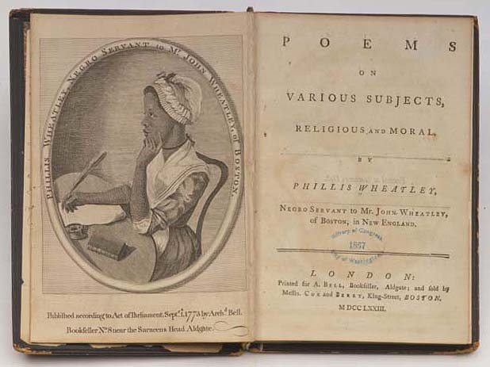

1. Phillis Wheatley was born in Africa and sold into slavery as a child. In light of that fact, what do you find surprising about the picture on the engraving?

2. At the time of publication, how do you think Phillis Wheatley would have described her occupation? How do you think Mr. John Wheatley, her owner would have described her occupation?

3. Using the information on the frontispiece, identify the location where Wheatley’s book was published and where it was sold. What possible explanation can be offered for the different location of publication and sale?

4. In 1776 Phillis Wheatley and George Washington exchanged letters. Wheatley praised Washington for his leadership, wishing him great future success. In his reply, Washington commented in very positive terms regarding her literary skills. Given the background of each, explain what made these communications unusual.

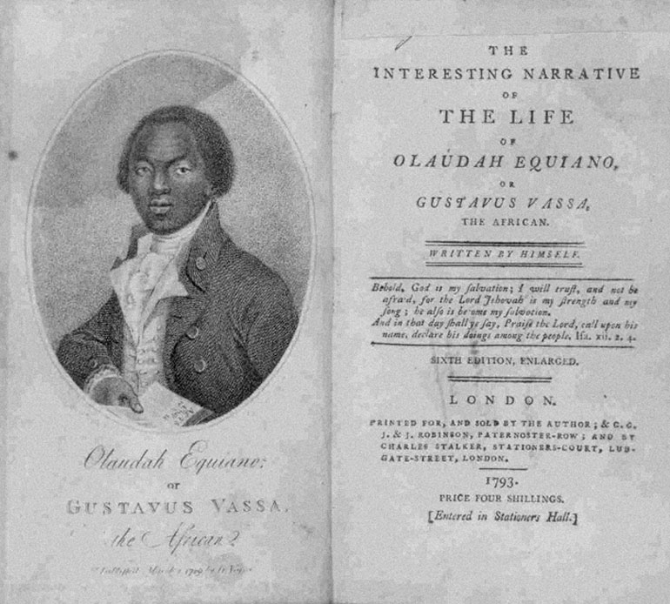

1. Olaudah Equiano wrote that he had been born in what is today Nigeria. At the age of eleven he was sold into slavery and forcibly brought to America. His book describes his capture and enslavement. Studying the picture of Equiano on the frontispiece, what question might you have for him?

2. In his book, Equiano vividly described the horrors of the “Middle Passage” – the treacherous ocean journey from Africa to the Americas. Why do you think he chose to describe this agonizing part of his life?

3. According to Equiano’s description of the “Middle Passage,” during the voyage some of his fellow Africans chose to jump overboard to their deaths. From your knowledge of the conditions on slave ships, how would you explain their actions?

4. From the drawing of Equiano on the frontispiece and the information on the title page, describe three ways in which his life changed after his capture.

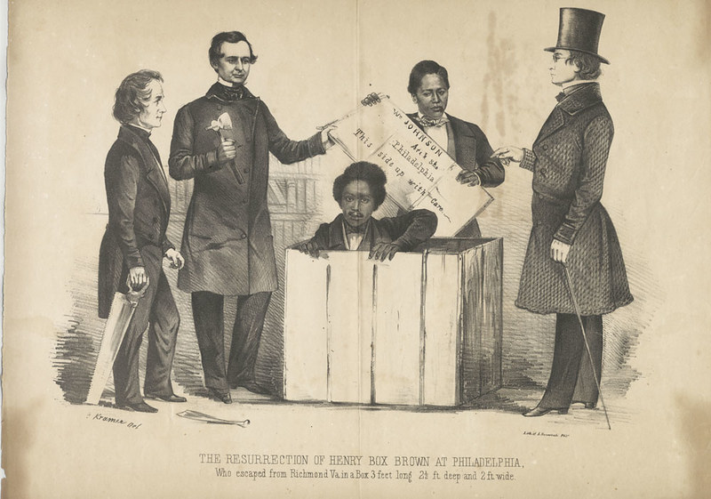

1. In 1849 Henry Brown sought to end his enslavement. Use the information in this print to piece together sufficient information to describe his escape.

2. Study the caption below the image. Why did the artist choose to use the word “resurrection” to describe Brown’s eventual condition?

3. Who do the figures greeting Brown represent? Describe their emotions.

4. Use your textbook to find a map of the United States, and locate Richmond, Virginia and Philadelphia, Pennsylvania. Brown was shipped by boat and carriage. Approximately how many miles did he travel in his box?

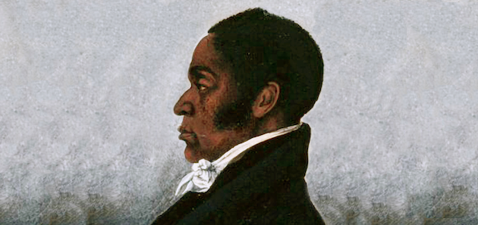

1. Born in 1766 of free black parents in Philadelphia, James Forten became a successful businessman. In 1813 he anonymously authored a pamphlet, Letters From A Man of Color, denouncing a bill before the Pennsylvania legislature requiring all black emigrants to Pennsylvania to register with the state. Why do you think he did not immediately take credit for this publication?

2. James Forten strongly opposed the American Colonization Society and its attempts to resettle black Americans in Liberia. Why did Forten oppose this organization?

3. From your knowledge of American history, explain why James Forten and William Lloyd Garrison became collaborators. (You may need to use the textbook to help answer this question.)

4. How did James Forten upset the views many white Americans commonly held of black Americans?

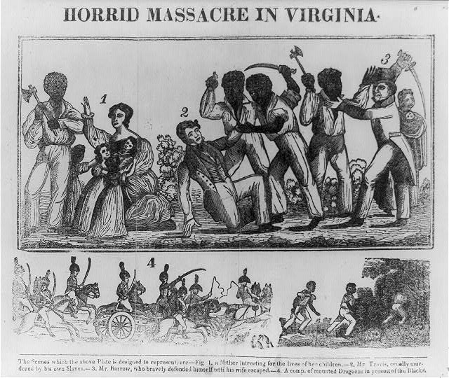

1. This woodcut was meant to illustrate events during the slave rebellion led by Nat Turner. Explain the point of view of the creator of this illustration.

2. Whose point of view is excluded in this illustration? Why?

3. This image was described as an “authentic and impartial narrative” of events. Drawing on your knowledge of American history, comment on the authenticity and impartiality of the illustration.

4. How would a depiction of this event drawn by a slave differ from this illustration?

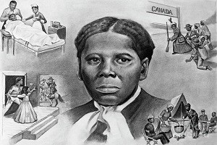

1. After Harriet Tubman escaped from slavery in 1849 she returned to the South numerous times to rescue members of her family and other slaves. Why is she considered courageous for these actions?

2. How did the Underground Railroad assist in the abolition movement?

3. Harriet Tubman has been referred to as a “modern day Moses.” Explain the reasons this nickname has been attached to her.

4. Carefully examine the image on this placard. What additional questions might you ask after viewing the drawing? What opinion do you think the artist had of Harriet Tubman?

