PBS’ Slavery by Another Name
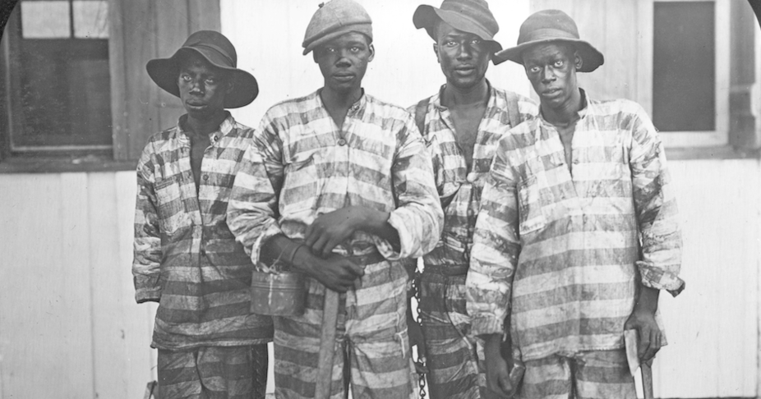
1. Explain debt peonage and how it operates.

2. How is peonage different from the slavery that existed in the South prior to the Civil War? How is it similar?

3. What role did contracts play in forced labor? How were contract terms extended?

4. Explain convict leasing and the purpose for it in the South after the 13th Amendment.

5. What impact did convict leasing have on blacks in the South?

6. How did sharecropping impact families like the Clemons?

7. Explain how the system of sharecropping kept impoverished Southerners in debt.

