Pleasantville
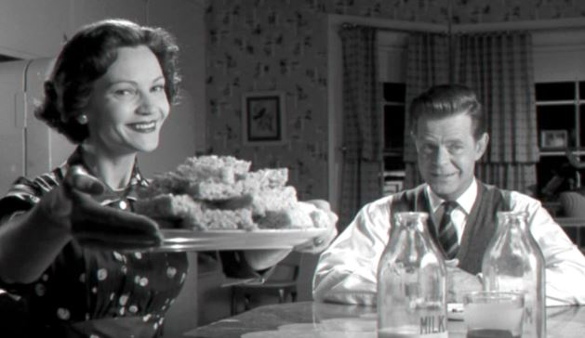

1. What details (clothing, dialogue, commercial goods) did you notice about life in 1950s Pleasantville? (Consider what Mary Sue & Bud noticed after they arrive)
2. What evidence was presented in the movie to indicate the roles men and women were expected to play both socially and economically in the 50s? What happens as those roles are challenged?
3. What sorts of things were parents worried about concerning what they perceived as teenage temptations? What threatened the “pleasant” nature of Pleasantville?
4. What evidence did you see of 1950s conformity? (Be sure to consider both material evidence as well as the values exhibited by the characters)
5. What behavior led people to change from black and white to Technicolor? As the film progresses, what different experiences “expose” the characters?
6. How did the town react to the changes they saw around them? (Be sure to use evidence from the film to support your answer)
7. Why was the unfamiliar threatening to some people in Pleasantville? What have we learned about during the 50s that threatened Americans living then?

Short Answer Reflection:
- What other unfamiliar, threatening things that actually happened in the 1950s that are met with fear and resistance? What connections can you make in the film?
- In what ways do you think the movie is an analogy for the transition from the 50s conformity to the tumult of the 60s?

Pleasantville

1. What details (clothing, dialogue, commercial goods) did you notice about life in 1950s Pleasantville? (Consider what Mary Sue & Bud noticed after they arrive)
2. What evidence was presented in the movie to indicate the roles men and women were expected to play both socially and economically in the 50s? What happens as those roles are challenged?
3. What sorts of things were parents worried about concerning what they perceived as teenage temptations? What threatened the “pleasant” nature of Pleasantville?
4. What evidence did you see of 1950s conformity? (Be sure to consider both material evidence as well as the values exhibited by the characters)
5. What behavior led people to change from black and white to Technicolor? As the film progresses, what different experiences “expose” the characters?
6. How did the town react to the changes they saw around them? (Be sure to use evidence from the film to support your answer)
7. Why was the unfamiliar threatening to some people in Pleasantville? What have we learned about during the 50s that threatened Americans living then?

Short Answer Reflection:
- What other unfamiliar, threatening things that actually happened in the 1950s that are met with fear and resistance? What connections can you make in the film?
- In what ways do you think the movie is an analogy for the transition from the 50s conformity to the tumult of the 60s?

