“PROJECT C”
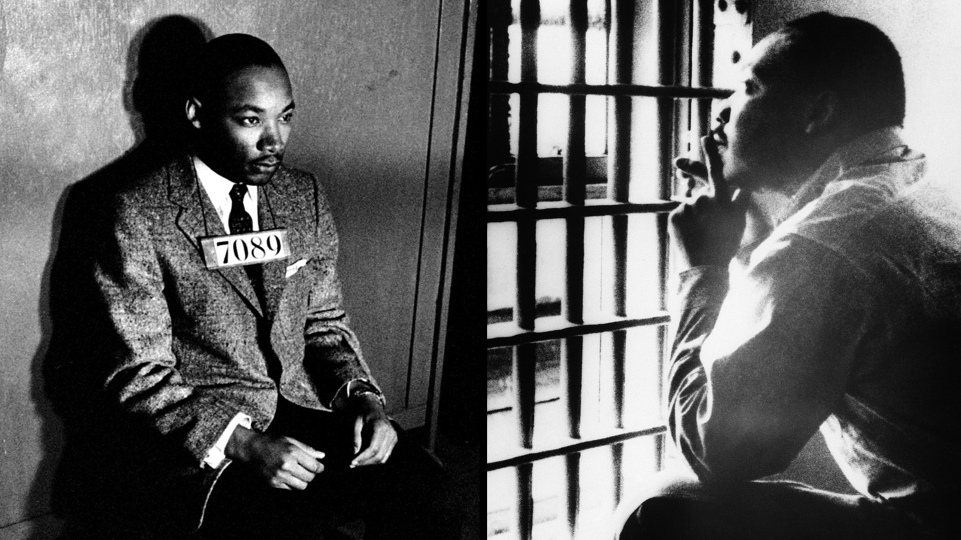
Martin Luther King Jr., head of the Southern Christian Leadership Conference, calls Birmingham, Alabama “the worst big city in race relations in the United States.” He writes this on December 17, 1962 in a telegram to President Kennedy after the bombing of Birmingham’s Bethel Church. Before that, when Bethel was Reverend Fred Shuttlesworth’s church, it had been bombed twice. These are just three in over fifty bombings in fifteen years, in a city that has segregation written in its laws and a police department, under the command of Eugene “Bull” Connor, which strictly enforces its codes.
A major demonstration in Birmingham could bring a much-needed victory for the civil rights movement. King works with Wyatt Tee Walker, Ralph Abernathy, Fred Shuttlesworth and other SCLC leaders to devise a plan. They call it Project C - ‘c’ for confrontation. Starting on April 3, 1963, it will build in waves, first with sit-ins, then a boycott, and finally, non-violent protest marches on a daily basis, which are likely to provoke heavy-handed reactions from police, with mass arrests. The media will cover it, and everyone will see why black people are asking for justice in the South. By the time the plan is launched, Birmingham has become a city with no stable government. Albert Boutwell has just won the city’s mayoral election, but his opponent, Bull Connor, is challenging the results. Connor, an out-and-out segregationist with a short fuse, is still in charge of the police force.
At first, few people join Project C. Store managers shut down their lunch counters in response to the sit-ins, few activists are arrested, and the news media pay little attention. On April 6, Shuttlesworth leads the first march and is arrested with forty people – still too few for a major impact. On April 12, Good Friday, King and Abernathy are arrested along with fifty others and spend the next eight days behind bars. During this period, King reads criticism of Project C by local white clergy in a smuggled-in newspaper. In its margins he begins to pen a response. One day, it will become famously known as his Letter from a Birmingham Jail.
While King is in jail, one of his young cohorts, James Bevel, begins to recruit and train youth to take part in non-violent marches. Word spreads, and soon students as young as six are ready to leave school and march in the streets. On May 2, they set forth on the first demonstration in what becomes known as the “Children’s March.” Police arrest over 600 young people, but 1,500 more are ready to take their place the next day. Bull Connor orders in police dogs and fire hoses. Images of people pummeled and drenched by high-pressure hoses, and snarling German shepherds tearing clothes off demonstrators highlight the evening news. With Birmingham’s jails overflowing, thousands more students join the demonstrations, sparking similar protests across the country. Before long, the story is making headlines around the world.
On May 5, Burke Marshall, Assistant Attorney General for Civil Rights, helps to get talks going between black and white community leaders in Birmingham. After several days of negotiations, a truce agreement is finally reached and announced to the press on May 10. In exchange for the civil rights groups ending the demonstrations, business leaders will take initial steps to integrate lunch counters, changing rooms, water fountains and restrooms at downtown stores, as well as open better job opportunities for blacks.
However, Alabama Governor George Wallace insists that no local or state officials have knowledge of “any so-called agreement.” On Saturday night, May 11, bombs explode at Martin Luther King Jr.’s headquarters at the Gaston Motel, and at the home of his brother, the Reverend A.D. King. Riots erupt and continue into the next morning.
On Sunday evening, in a radio and TV broadcast from the White House, President Kennedy announces that he’s sending Burke Marshall back to Birmingham to consult with local citizens, ordering Armed Forces units to bases in the vicinity, and taking preliminary measures to federalize the Alabama National Guard “should their services be required.” Governor Wallace is outraged and accuses the president of disregarding the sovereignty of the state of Alabama.
Despite the violence and continued opposition by white extremists, the shaky peace agreement holds and by mid-summer the city council will vote to repeal Birmingham’s segregation ordinances. Project C has succeeded, and young people have made a difference.
Directions: please answer the following questions based on “Letter from a Birmingham Jail” and the information above on “Project C”.

1. How does King explain why he urges people to obey the Supreme Court’s decision outlawing segregated public schools and then breaks laws that he disagrees with?
2. Any law that degrades a person is unjust, according to Dr. King. What does “degrade” mean? In what way does he think segregation is degrading to the individual?
3. What is the connection that King sees between unjust laws and racial discrimination in voting?
4. When he says that a law can be “just on its face but unjust in its application,” what example does he give?
5. What attitude does King say one should adopt if breaking an unjust law?
  - 6. King does not use the term “civil disobedience.” Research this term and then explain whether Dr. King’s actions meet the definition.

