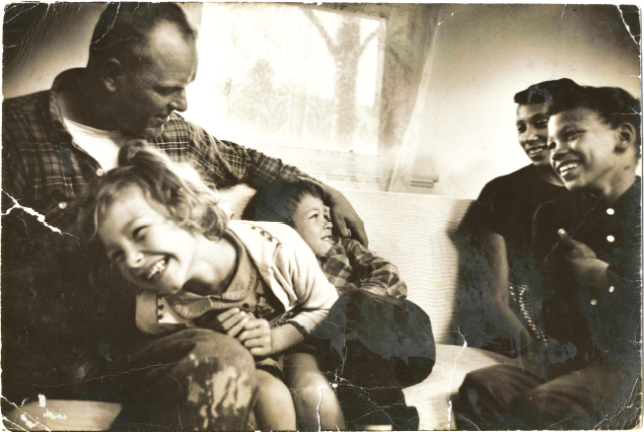
Loving

1. Before you view the film, put together the facts of the case in a timeline format starting with the marriage of the Lovings to the decision made by the Supreme Court and its impact.
2. For the state of Virginia:
• What did it argue should be preserved among its citizens?
• To whom did it say the law applied?
• Who did it think needed protection from interracial marriage?
3. For the ACLU representing the Lovings:
• What did their lawyers argue had been violated?
• What previous case had created a precedent for striking down Virginia’s law?
4. What path did the Loving case follow through the courts? Why is that path important?
5. Why was the intervention by the ACLU so significant for the Lovings’ situation? Think about accessibility to adequate legal assistance, knowledge of the court system, Constitutional rights and protections, etc.

Short Answer Reflection:
- Explain how three other events not included in the film coincided historically with the Loving case. How are these three surrounding events significant to the Loving case? (Analyze the connections like you would a “historic contextualization”)

