Martin Luther King Jr. on Just and Unjust Law
Excerpts from a letter to fellow clergymen written from Birmingham City Jail, April 16, 1963
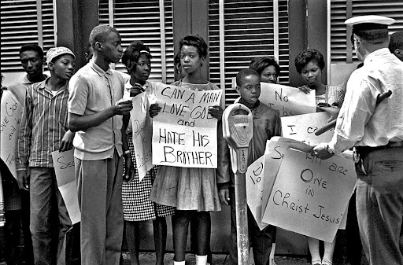
“You express a great deal of anxiety over our willingness to break law. This is certainly a legitimate concern. Since we so diligently urge people to obey the Supreme Court’s decision of 1954 outlawing segregation in the public schools, it is rather strange and paradoxical to find us consciously breaking laws. One may well ask, “How can you advocate breaking some laws and obeying others?” The answer is found in the fact that there are two types of laws: There are just laws and there are unjust laws. I would be the first to advocate obeying just laws. One has not only a legal but a moral responsibility to obey just laws. Conversely, one has a moral responsibility to disobey unjust laws.

….. Any law that uplifts human personality is just. Any law that degrades human personality is unjust. All segregation statutes are unjust because segregation distorts the soul and damages the personality. It gives the segregated a false sense of inferiority.

….. Let us turn to a more concrete example of just and unjust laws. An unjust law is a code that a majority inflicts on a minority that is not binding on itself. This is difference made legal. On the other hand, a just law is a code that a majority compels a minority to follow that it is willing to follow itself. This is sameness made legal. Let me give another explanation. An unjust law is a code inflicted upon a minority which that minority had no part in enacting or creating because they did not have the unhampered right to vote. Who can say the legislature of Alabama which set up the segregation laws was democratically elected? Throughout the state of Alabama all types of convenient methods are used to prevent Negroes from becoming registered voters and there are some counties without a single Negro registered to vote despite the fact that the Negro constitutes a majority of the population. Can any law set up in such a state be considered democratically structured?

….. There are some instances when a law is just on its face but unjust in its application. For instance, I was arrested Friday on a charge of parading without a permit. Now there is nothing wrong with an ordinance which requires a permit for a parade, but when the ordinance is used to preserve segregation and to deny citizens the first amendment privilege of peaceful assembly and peaceful protest, then it becomes unjust. I hope you can see the distinction I am trying to point out. In no sense do I advocate evading or defying the law as the rabid segregationist would do. This would lead to anarchy. One who breaks an unjust law must do it openly, lovingly…and with a willingness to accept the penalty. I submit that an individual who breaks a law that conscience tells him is unjust, and willingly accepts the penalty by staying in jail to arouse the conscience of the community over its injustice, is in reality expressing the very highest respect for the law.”

