Iron Jawed Angels
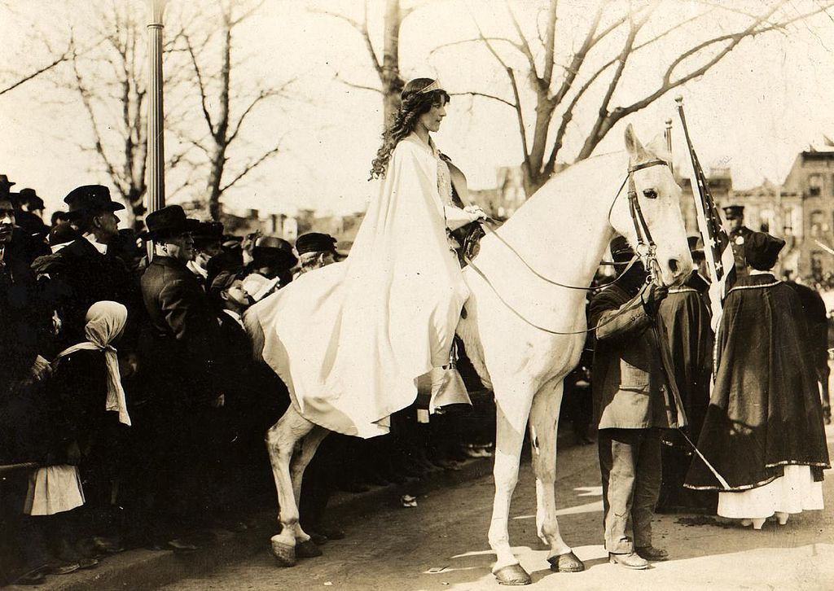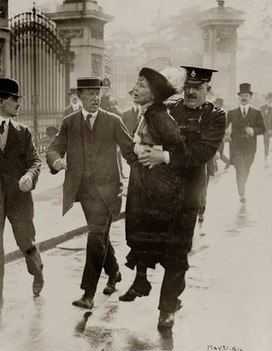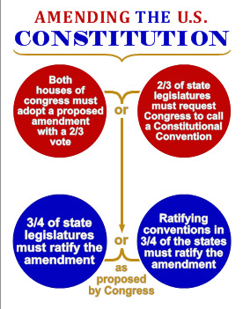

During the film:
- Why does Ida Wells-Barnett from the Chicago delegation take issue with the parade?
- Explain why Carrie Chapman Catt and Anna Shaw disapprove of Alice Paul’s tactics and strategy.
- Wilson advised the delegation to continue campaigning for suffrage state by state, dodging the request to support women’s suffrage. Why do you think he wanted them to use that method instead?
- In what ways do the district commissioners attempt to curb the picketing of the National Woman’s Party?
- Which rights are being violated from the parade all the way through to their imprisonment? Explain which rights and provide evidence of them being violated.
- Why does Alice Paul distinguish between President Wilson and the office of the president in her statement to the psychologist?
- Why does President Wilson ultimately address Congress in support of the passage of the 19th Amendment?

After the film:
- Research and explain the tactics used during the Women’s Rights Movement of the 1800s by women like Carrie Chapman Catt and Anna Shaw. Compare their strategies to have women granted the right to vote to women like Alice Paul and Lucy Burns.

