Iron Jawed Angels
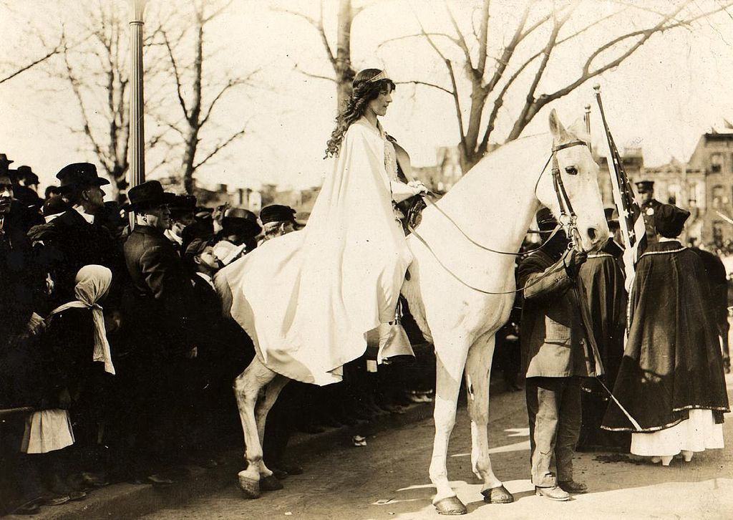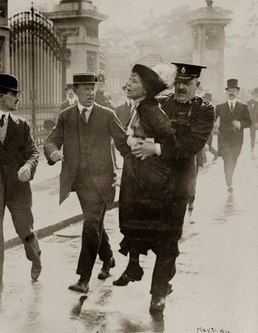

Before the film, answer these following questions using www.history.com as your source (use complete sentences).

- What is the process for ratifying a constitutional amendment? Describe the different steps and ways that one can be passed.
- How did the suffragettes in England “get the vote”? What were their methods of protesting?

During the film, answer the following questions in complete sentences.

- What event does Alice Paul bring up to gain support with female factory workers?
- Why does Ida Wells-Barnett from the Chicago Delegation take issue with the parade?
- Why are Carrie Chapman Catt and Anna Shaw dissatisfied with Alice Paul’s tactics?
- In what ways do the district commissioners attempt to curb the National Women’s Party from picketing?
- Why does their protest become increasingly unpopular?
- During her interview with the psychologist, why does Alice distinguish between President Wilson and the office of the presidency?
- What state’s legislature was crucial in the ratification of the 19th Amendment?

