Iron Jawed Angels
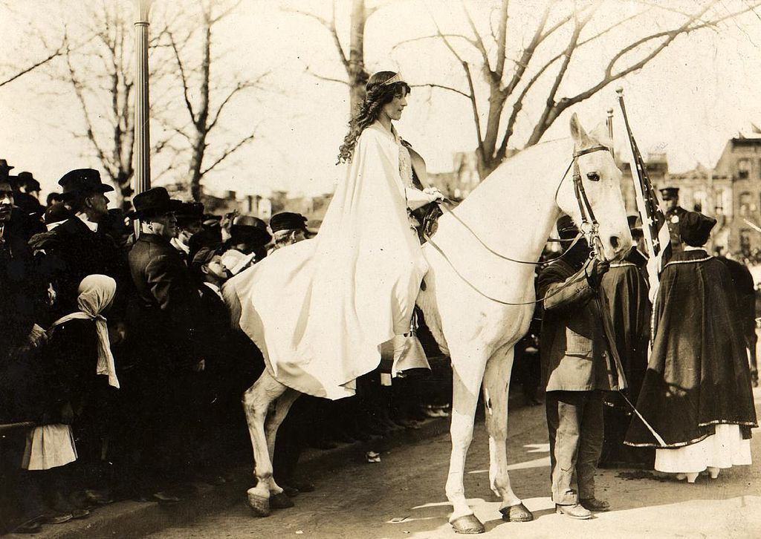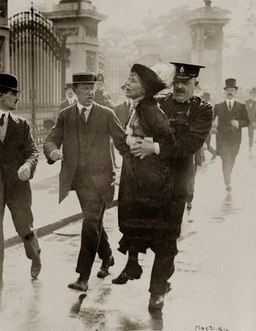

Before the film:
- What is the necessary process to ratify a constitutional amendment?
- Research and explain the tactics used during the Women’s Rights Movement of the 1800s by women like Carrie Chapman Catt and Anna Shaw.

During the film:
- What event does Alice Paul bring up to gain support with female factory workers?
- Why does Ida Wells-Barnett from the Chicago delegation take issue with the parade?
- Explain why Carrie Chapman Catt and Anna Shaw disapprove of Alice Paul’s tactics and strategy.
- Wilson advised the delegation to continue campaigning for suffrage state by state, initially dodging the request to support women’s suffrage. Why do you think he made this distinction in their methodology?
- In what ways do the district commissioners attempt to curb the NWP’s picketing?
- Why does Alice distinguish between President Wilson and the office of the presidency in her statement to the psychologist?

