Iron Jawed Angels
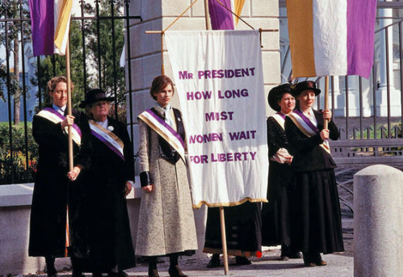

- Why do the leaders of the National American Woman’s Suffrage Association disassociate with British suffragettes? (If you need help with this, research English suffragette Emmeline Pankhurst.)
- What event does Alice Paul bring up to gain support with female factory workers?
- Why does Ida Wells-Barnett from the Chicago delegation take issue with the parade?
- Why are Carrie Chapman Catt and Anna Shaw dissatisfied with Alice Paul’s tactics? Research and compare the differences in tactics from the suffrage movement of the 1800s to that of the early 1900s.
- Wilson said he was focused on currency and tariff reform during his campaign. How does he achieve these goals during his administration? (Support with SFI.)
- Wilson advised the delegation to continue campaigning for suffrage state by state but refused to support a national amendment. Why do you think he made this distinction in their methodology?
- In what ways do the district commissioners attempt to curb the NWP’s picketing? Why does it become increasingly unpopular?
- Why does Alice distinguish between President Wilson and the office of the presidency in her statement to the psychologist?
- What is the necessary process to ratify a constitutional amendment? What state’s legislature was crucial in the ratification of the 19th Amendment?
- The film ends by stating that Alice Paul continued to fight for women’s rights. Research and explain her role in the following decades regarding women’s rights (in the U.S. and internationally).

Short Answer Reflection

- Read the article regarding Eleanor Roosevelt’s opposition to the National Women’s Party. Discuss the two opposing arguments made by Roosevelt and the NWP.

Iron Jawed Angels

- Why do the leaders of the National American Woman’s Suffrage Association disassociate with British suffragettes? (If you need help with this, research English suffragette Emmeline Pankhurst.)
- What event does Alice Paul bring up to gain support with female factory workers?
- Why does Ida Wells-Barnett from the Chicago delegation take issue with the parade?
- Why are Carrie Chapman Catt and Anna Shaw dissatisfied with Alice Paul’s tactics? Research and compare the differences in tactics from the suffrage movement of the 1800s to that of the early 1900s.
- Wilson said he was focused on currency and tariff reform during his campaign. How does he achieve these goals during his administration? (Support with SFI.)
- Wilson advised the delegation to continue campaigning for suffrage state by state but refused to support a national amendment. Why do you think he made this distinction in their methodology?
- In what ways do the district commissioners attempt to curb the NWP’s picketing? Why does it become increasingly unpopular?
- Why does Alice distinguish between President Wilson and the office of the presidency in her statement to the psychologist?
- What is the necessary process to ratify a constitutional amendment? What state’s legislature was crucial in the ratification of the 19th Amendment?
- The film ends by stating that Alice Paul continued to fight for women’s rights. Research and explain her role in the following decades regarding women’s rights (in the U.S. and internationally).

Short Answer Reflection

- Read the article regarding Eleanor Roosevelt’s opposition to the National Women’s Party. Discuss the two opposing arguments made by Roosevelt and the NWP.

