French and Indian War: Causes and Effects

Causes of conflict between the French and British colonies:
1.

2.

3.

WAR FROM:
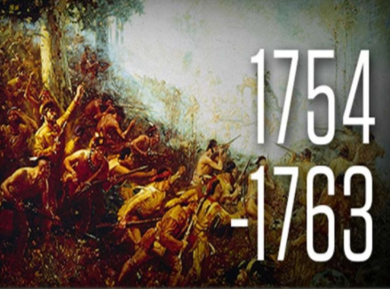
Belligerents:
French and _____________
_____________ Native American tribes
VS
British, British colonists, and _______________
_______________
Native American tribes

Effects of the F&I War

British Response

