Far and Away
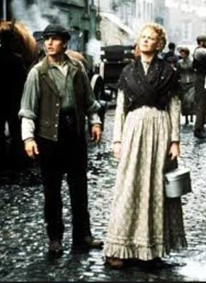

1. How does the film illustrate the oppression of tenant farmers in Ireland?
2. How does the Christie “manor” compare to the Donnelly “croft”? How comparable is it to the wealth gap in the U.S. at the time?
3. When Joseph awakens in the Christie manor, what desire – common to most immigrants – is his ultimate dream?
4. How does the Christie family’s treatment of Shannon mirror America’s “Cult of Domesticity”?
5. Why would the Irish tend to gravitate to the ward boss’ Social Club?
6. Give specific examples of how the Irish are treated in America.
7. What services does the Mike Kelly provide Joseph and Shannon? In what ways did this “help” hurt local immigrants and also help them?
8. How does Shannon’s exchange of insults with the floor manager reflect the power of employers over unskilled laborers during the Gilded Age?
9. What would middle-class Protestants have thought of the activities of the Irish Social Club?
10. Politicians and factory owners encouraged inter-ethnic sports competitions. Why?
11. How could these events support the “status quo”? Side fact: the introduction of elaborate boxing rules was an attempt to reclaim the sport of boxing from rowdy immigrants.*
12. How does the eviction scene demonstrate the ward boss’ power over the police and economic activity in these inner-city areas?
13. How are Joseph and Shannon treated by the public as they search for work and shelter? What enables them to treat them that way?
14. Describe Joseph’s life working for the railroad based on what you know from Period 6.
15. How do the Oklahoma homesteaders stake their claim? How does this method reflect how American “character” has developed?
16. What factors would make some sections of land more valuable than others? What is the significance of the camera on the Native Americans before the race begins?

Short Answer Reflection:

- In what ways does our “American identity” develop during Period 6? Site specific examples referred to in the film as they correlate with content from Period 6.

Far and Away

1. How does the film illustrate the oppression of tenant farmers in Ireland?
2. How does the Christie “manor” compare to the Donnelly “croft”? How comparable is it to the wealth gap in the U.S. at the time?
3. When Joseph awakens in the Christie manor, what desire – common to most immigrants – is his ultimate dream?
4. How does the Christie family’s treatment of Shannon mirror America’s “Cult of Domesticity”?
5. Why would the Irish tend to gravitate to the ward boss’ Social Club?
6. Give specific examples of how the Irish are treated in America.
7. What services does the Mike Kelly provide Joseph and Shannon? In what ways did this “help” hurt local immigrants and also help them?
8. How does Shannon’s exchange of insults with the floor manager reflect the power of employers over unskilled laborers during the Gilded Age?
9. What would middle-class Protestants have thought of the activities of the Irish Social Club?
10. Politicians and factory owners encouraged inter-ethnic sports competitions. Why?
11. How could these events support the “status quo”? Side fact: the introduction of elaborate boxing rules was an attempt to reclaim the sport of boxing from rowdy immigrants.*
12. How does the eviction scene demonstrate the ward boss’ power over the police and economic activity in these inner-city areas?
13. How are Joseph and Shannon treated by the public as they search for work and shelter? What enables them to treat them that way?
14. Describe Joseph’s life working for the railroad based on what you know from Period 6.
15. How do the Oklahoma homesteaders stake their claim? How does this method reflect how American “character” has developed?
16. What factors would make some sections of land more valuable than others? What is the significance of the camera on the Native Americans before the race begins?

Short Answer Reflection:

- In what ways does our “American identity” develop during Period 6? Site specific examples referred to in the film as they correlate with content from Period 6.

