PBS’ The Murder of Emmett Till
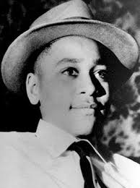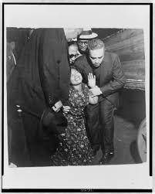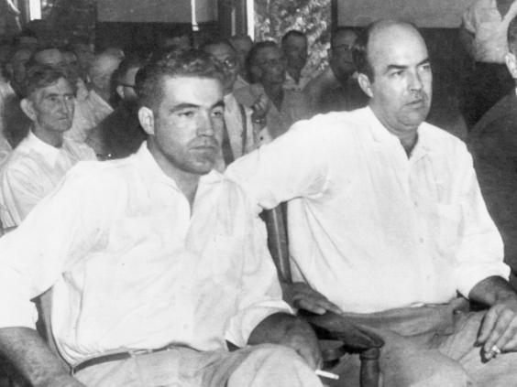

Part I
In a paragraph, use evidence from the video as it progresses to explain the social conditions of the South compared to those Mamie and Emmett experienced in Chicago.

Part II
Create a timeline of the events of the trial of Milam and Bryant.

Part III
Explain why was this one of the significant “moments” in the Civil Rights Movement, even though it happens in 1955. Despite the outcome of the trial, what is the legacy of Emmett Till?

