Delegates of the Constitutional Convention Research
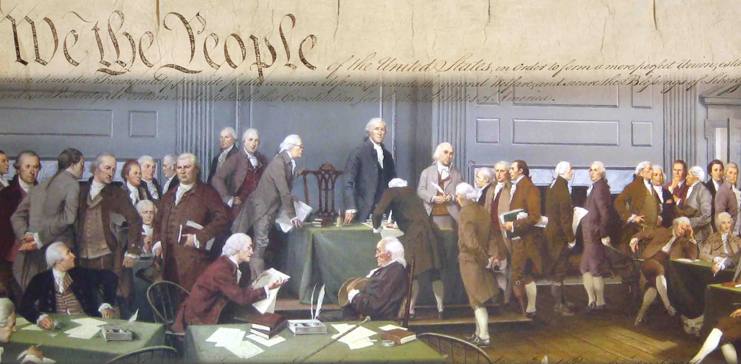
After the events of Shays’ Rebellion, men later to be known as the Founding Fathers secretly came together in Philadelphia, Pennsylvania to discuss revising the Articles of Confederation.

You have been given a delegate who attended. Answer the following questions in complete sentences using the website below. https://teachingamericanhistory.org/resources/convention/delegates/

- Background
  - What state is your delegate from?

  - Give me a brief summary of their early life.

  - Explain his lifetime career (explain, not just list).

- Influence During the Revolutionary Period
  - Was your delegate a signer of the Declaration of Independence?

  - How did he participate in the Revolution? (e.g. was he a member of the 1st or 2nd Continental Congress, veteran, etc.)

  - Was he a Patriot or a Loyalist?

- Issues at the Convention
  - Does your delegate support the Virginia (large state plan) or New Jersey (small state plan) Plan regarding how many legislators each state would receive?

  - Why did he feel strongly about either of the two plans?

  - Does he support the institution of slavery? Did he own slaves?

  - Did he support a strong central government or power in the states (and therefore the people)?

- After the Convention:
  - What does he do after the Constitutional Convention ended? (e.g. becomes president, becomes a governor, congressman, etc.)

  - Give one additional noteworthy fact about your delegate’s life.

