Bridge of Spies

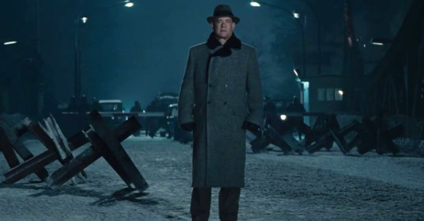

- Explain why Rudolf Abel asks to clean up his paints.
- List and explain the three charges against Abel.
- When Donovan visits the judge at his home, explain why Donovan believes it isn’t in the United States’ best interest to execute Rudolf Abel.
- Explain why Yale Frederic Pryor crosses over to East Germany. What is his significance in this case?
- Explain the dialogue between the Soviet representative and Mr. Donovan at the Soviet Embassy.
- Explain the details of the prisoner trade-off. (e.g., location, concerns, stipulations, etc.)

Short Answer Reflection

- Explain the differences in the two cases of Rudolf Abel’s and Julius and Ethel Rosenberg’s.
- Research the critics who disliked this film. In what ways were they critical of Spielberg’s depiction of these Cold War events? How would they feel about it being used to teach “History Through Film”?

Bridge of Spies

- Explain why Rudolf Abel asks to clean up his paints.
- List and explain the three charges against Abel.
- When Donovan visits the judge at his home, explain why Donovan believes it isn’t in the United States’ best interest to execute Rudolf Abel.
- Explain why Yale Frederic Pryor crosses over to East Germany. What is his significance in this case?
- Explain the dialogue between the Soviet representative and Mr. Donovan at the Soviet Embassy.
- Explain the details of the prisoner trade-off. (e.g., location, concerns, stipulations, etc.)

Short Answer Reflection

- Explain the differences in the two cases of Rudolf Abel’s and Julius and Ethel Rosenberg’s.
- Research the critics who disliked this film. In what ways were they critical of Spielberg’s depiction of these Cold War events? How would they feel about it being used to teach “History Through Film”?

