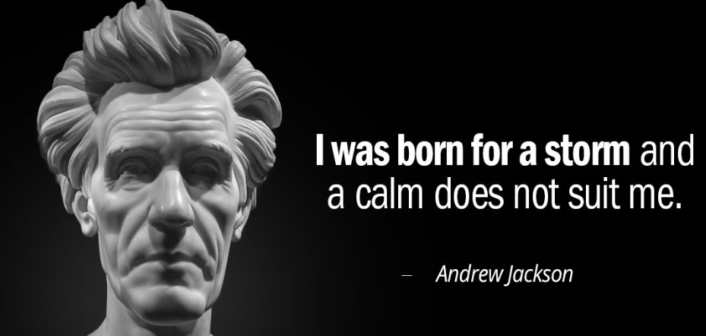
Andrew Jackson: The Good, Evil, and the Presidency
Reinventing the Presidency (start at 44 minutes)
- How were presidential candidates initially selected before Jackson’s presidency?
- Explain Jackson’s strategy of the 1828 campaign.
- Explain the impact of Jackson’s wife Rachel on his presidency.

Nullification Crisis
- Explain the issue that John C. Calhoun obsessed over.
- Explain the difficulties Southern planters and slaveholders felt they faced.
- What did Jackson say at the Jefferson birthday celebration? What was his stance on nullification?
- How did Jackson attempt to solve the nullification crisis?
- What did Jackson argue in his proclamation?
- How was a civil war finally avoided? What was the solution to the “Nullification Crisis”?

Indian Removal Act
- Explain Jefferson's vision of America.
- Explain the ways that the Cherokees took Jefferson’s advice and why, despite following Jefferson's advice, were the Cherokees removed?
- While Jackson hoped to be called "Great Father" by the Cherokees, what name did they actually use?
The Bank War
- What did Jackson dislike about the Bank of the United States?
- Who was Jackson’s enemy in the Bank War and why did Jackson veto the bill that would extend the charter of the 2nd Bank of the United States?
Cherokee Nation Appeals to the Supreme Court
- Explain how the Cherokees attempted to fight removal and Jackson’s response to the Supreme Court's decision.
The Corporations
- What was Jackson's economic vision for America?
- What was Jackson specifically worried about regarding the U.S. economy and why did he distrust corporations?
- What warning did Jackson issue in his farewell address?

