PBS’ American Experience: The Candy Bomber
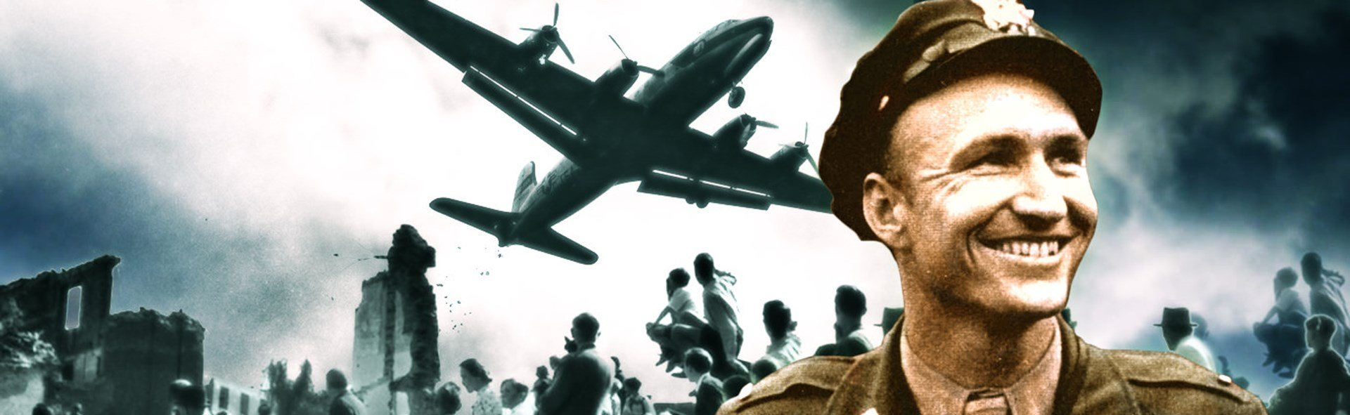
Task I
As you watch the documentary, create a timeline of events of the Berlin Blockade and the Berlin Airlift.
Task II
Answer questions below in complete sentences.
- Why did the airlift at first seem impossible?

- Explain why it was deemed important to accomplish this mission.

- What were some of the most important items shipped to the people of Berlin?

- Describes some of the difficulties faced by the pilots and ground people during the Airlift.

- Explain the different ways the people of Berlin responded to the Airlift.

- In what ways did the Berlin Airlift shape the future of Berlin as well as the Cold War? Did capitalism or communism win?

