PBS: The Candy Bomber
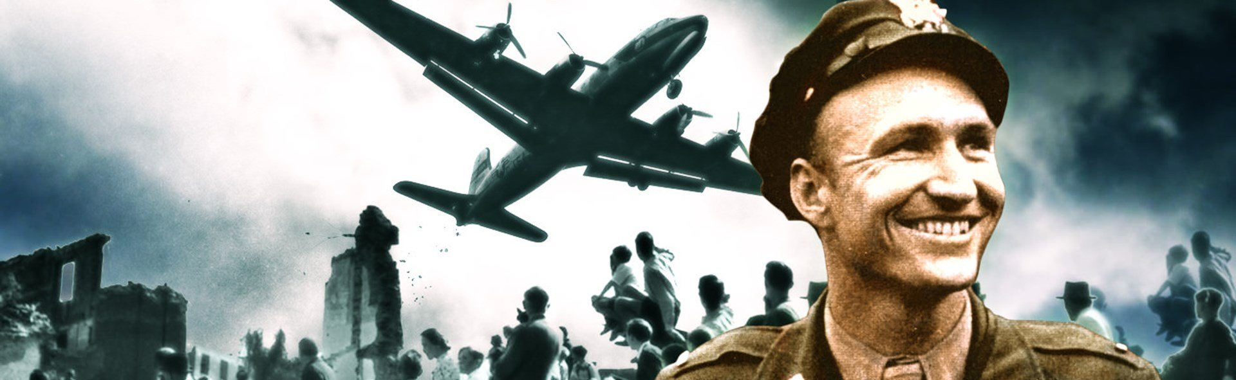
Task I
Create a timeline of events of the Berlin Blockade and the Berlin Airlift.
Task II
Answer questions below on a separate sheet of paper.
- Why did this task at first seem insurmountable?

- Why was it deemed important to accomplish this mission?

- What were some of the most important items shipped to the people of Berlin?

- What were some of the problems faced by the pilots and ground people during the Airlift?

- How did the people of Berlin respond to the Airlift?

- How did the Airlift shape the future of Berlin as well as the Cold War?

