The Jazz Age, The Roaring 20s, and the Era of Prohibition
Directions: PLEASE ANSWER THESE QUESTIONS ON YOUR OWN SHEET OF PAPER
Area 1: The Government and Business
1. Copy this chart on your own paper and fill it in:
President | Party | Years in Office | Foreign Policy | Domestic Policy
Warren G. Harding
Calvin Coolidge
Herbert Hoover

1. What do all the presidents of the 1920s have in common?
2. What electrical appliances became popular in the 1920s? http://www.ushistory.org/us/46f.asp
3. What was the biggest form of media in the 1920s? What kind of culture did it create? http://www.ushistory.org/us/46g.asp
4. What invention did Henry Ford create that assisted in the manufacturing of cars? http://www.ushistory.org/us/46a.asp
5. Explain mass production and mass consumption.
6. If you wanted to buy a Model T in 1914 what colors could you choose from?
7. What were some consequences of the car?
Area 2: Leisure Time, Fads, and Literature
1. What is a flapper? Describe how they would look and act. What did they do that was controversial? http://www.ushistory.org/us/46d.asp
2. Name two famous aviators in this time period. (Hint: one was a woman) What were they known for? http://blogs.smithsonianmag.com/aroundthemall/2010/05/celebrating-milestones-of-flight-lindbergh-and-earhart-cross-the-atlantic/
3. What was the Spirit of St. Louis?
4. Name two famous athletes of the 1920s. What sport did they play? http://www.ushistory.org/us/46h.asp
5. Who wrote The Great Gatsby? What wa one of the themes of the novel? http://www.ushistory.org/us/47d.asp
6. Who were the writers of The Lost Generation? What did they write about?
7. What style of music became popular in the 1920s?
Area 3: Jazz and Harlem Renaissance http://www.ushistory.org/us/46e.asp
1. Give examples of push and pull factors for migration?
2. What factors “pushed” blacks to seek a better life in the North?
3. What “pull” factors led to the Great Migration of the 1910s-1920s?
4. Why was Louis Armstrong such an influential musician? What was his nickname?
5. Describe the Harlem Renaissance.
6. Why was Langston Hughes such an influential author?
7. Describe the artwork by Georgia O’Keeffe. How does her painting The American Radiator portray the 1920s? What else did she enjoy painting? https://upload.wikimedia.org/wikipedia/en/a/a2/Radiator_Building_-_Night%2C_New_York%2C_1927.jpg
Area 4: Prohibition
1. Explain the Volstead Act. https://www.history.com/this-day-in-history/congress-enforces-prohibition
2. According to the political cartoon, why would the government want to prohibit saloons and alcohol? List 2 reasons. (hint, look at the tentacles) (If the carton is too small to read CLICK HERE)
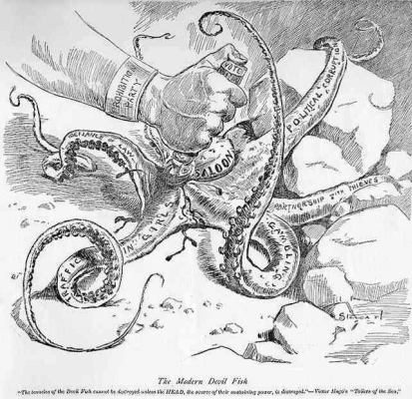
3. Who was Al Capone? http://www.ushistory.org/us/46b.asp
4. What amendment brought the end to Prohibition? When was it ratified? http://www.ushistory.org/us/46b.asp
Area 5: A Growing Intolerance
1. What is Nativism? Why did the 1920s see a new wave of Nativism?
2. The Ku Klux Klan of the 1920s was known for their intolerance of many groups of people. Name at least 2 groups and explain their opposition to those groups. https://www.theatlantic.com/politics/archive/2016/12/second-klan/509468/
3. Why was John T. Scopes put on trial? http://www.ushistory.org/us/47b.asp
4. Why was the Scopes trial also known as the “monkey” trial?
7. This trial was a showdown between what two groups? What was the outcome of the trial?

