Thirteen Days
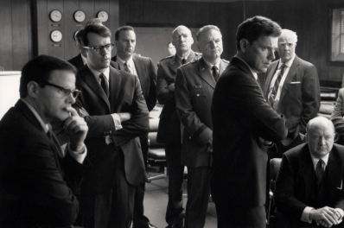

- Explain the Joint Chief’s recommendation upon the discovery of the missiles.
- What is President Kennedy’s reservation about the consequences of military action?
- What is the idea Bob McNamara proposes in ExCOMM?
- Explain why it’s important for President Kennedy to maintain his schedule during negotiations.
- Why is the action referred to as a “quarantine” rather than a “blockade”?
- How does President Kennedy get the editor of the NY Times to hold the story?
- What does O’Donnell mean when he says “they don’t even think we deserve to be here”?
- Explain the plan for the approaching Soviet ships?
- Why does President Kennedy need a vote of support from the Organization of American States?
- Explain Adlai Stevenson’s task at the United Nations.
- What message is passed to Khrushchev through Aleksandr Fomin?
- What could have been disastrous for negotiations? (2 issues)

Short Answer Reflection

- General Curtis LeMay has stated that giving in to Soviet demands during the CMC was the worst defeat of the U.S. in its entire history. Support or refute this statement using historical evidence.

