Actor/Picture | Portraying: | Title/Role in the CMC/Position on what actions should be taken
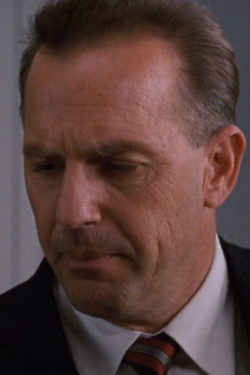 | Kenny O’Donnell | Special assistant and appointments secretary
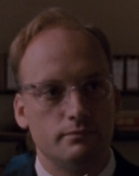 | McGeorge Bundy | National Security Advisor
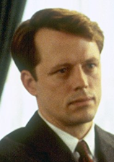 | Bobby Kennedy | Attorney General
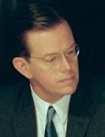 | Robert MacNamara | Secretary of Defense
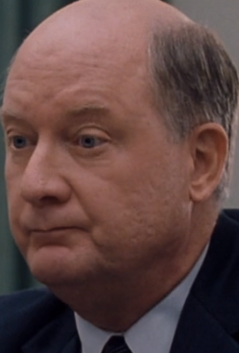 | Dean Rusk | Secretary of State
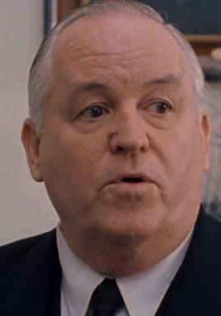 | Arthur Lundahl | Imagery intelligence expert
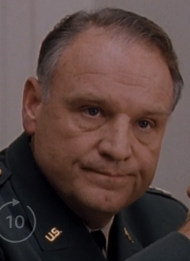 | General Maxwell Taylor | Chairman of the Joint Chiefs
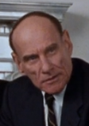 | Adlai Stevenson | Ambassador to the UN
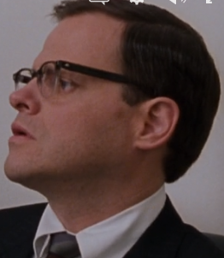 | Ted Sorenson | Special counsel to the president
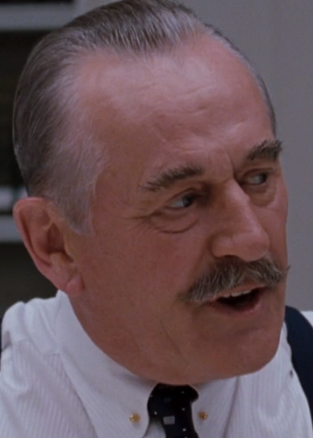 | Dean Acheson | Former Secretary of State under Truman (a developer of the Marshall Plan and NATO)
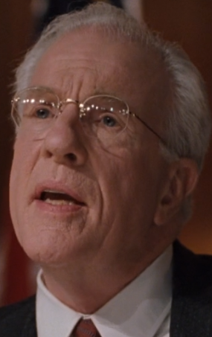 | John McCone | Director of the CIA during crisis
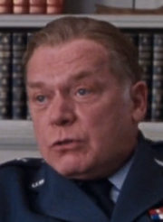 | General Curtis LeMay | Air Force Chief of Staff
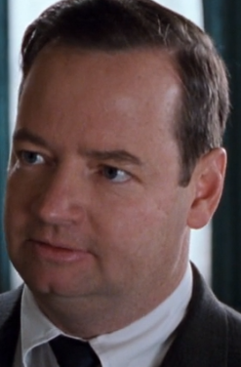 | Pierre Salinger | White House Press Secretary
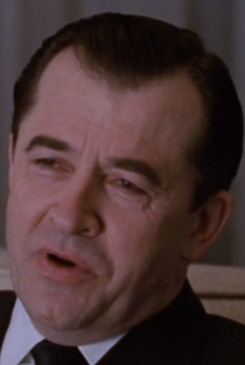 | Andrei Gromyko | Foreign Minister of the USSR
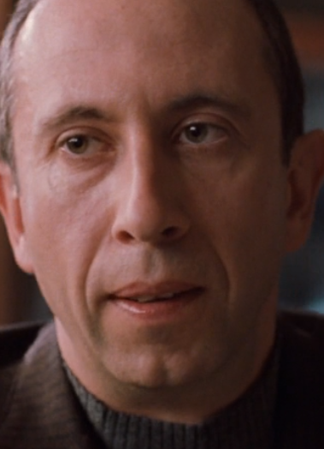 | Anotoly Dobrinyn | Soviet Ambassador to the U.S.

