Period 1 & 2 Multiple Choice Practice Questions
“And it is further enacted by the authority aforesaid, that form and after the first day of April, which shall be in the year of our Lord one thousand six hundred sixty-one, no sugars, tobacco, cotton-wool, indigoes, ginger, fustic, or other dyeing wood, of the growth, production, or manufacture of any English plantations in America, Asia, or Africa, shall be shipped, carried, conveyed, or transported from any of the said English plantations to any land, island, territory, dominion, port, or place whatsoever, other than to such other English plantations as do belong to his Majesty, his heirs and successors, or to the kingdom of England or Ireland, or principality of Wales, or town of Berwick upon Tweed, there to be laid on shore…”
–Excerpt from the Navigation Acts (1660-1696)
- Acts such as the one above encouraged
- The growth of the shipbuilding industry in New England
- The production of diversified food crops in the South
- The dominance of manufacturing industries in the middle colonies
- An increased demand for indentured servants by 1700

- Which of the following is NOT true of the series of English acts that regulated trade during the 17th century?
- They benefitted both the colonies and England in certain ways
- They were largely ignored by the American colonies if they were not beneficial
- They required that colonial goods be carried in English ships with English crews
- They sparked frequent violent rebellions over British authority beginning with King Philips’ War

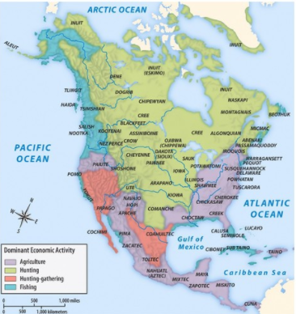
- American Indian cultures
- Established a common written language
- Established trade networks and communication over relatively large areas
- Had peaceful relationships with each other that included voluntary emigration
- Formed major alliances to combat attempts by Europeans to encroach on their lands

- Prior to European contact, North American Indians were
- Dominated by the Plains Indians, who possessed horses
- Dominated by the eastern woodland tribes, who possessed firearms
- Depended on imports of foodstuffs from Mexican tribes for survival
- Distinct societies with different economies and lifestyles

“That for all persons…which during the next seven years after Midsummer Day 1618 shall go into Virginia with intent there to inhabit, if they continue there three years or die after they are shipped there shall be a grant made of fifty acres for every person…which grants to be made respectively to such persons and their heirs at whose charges the said persons going to inhabit in Virginia shall be transported.”
-Virginia Company Instructions to Sir George Yeardley, 18 November 1618

- The system described above was primarily initiated to
- Protect colonists settling in Virginia from attacks by American Indians
- Encourage the growth of an elite class of plantation owners
- Provide an adequate labor force to make the land profitable
- Encourage the deportation of undesired persons from England

- Because no such system was established in New England
- The average size of landholdings was smaller in NE than in the Chesapeake
- NE was the last colonial region to become “overpopulated”
- African slaves became the chief labor source in NE
- The Chesapeake colonies became more homogenous than NE in both religion and ethnic background

“[New Englanders] are at present a numerous and thriving people and in 20 years more are likely…to be mighty rich and powerful and not at all careful of their dependence upon old England…I take the way of roughness and peremptory orders, with force to back them, to be utterly unadvisable. For they are already too strong to be compelled…and though I apprehend them yet not at that point to cast us off voluntarily and of choice; yet I believe if we use severity towards them in their government civil or religious, that they will (being made desperate) set up for themselves and reject us.”
-Earl of Sandwich, “Comments upon New England,” 1671

- Which of the following is best reflected by the above passage?
- New England was threatening the world trade dominance of Great Britain in the late seventeenth century
- The majority of American colonists favored separation from Great Britain in 1671
- Britain’s inability to provide the colonists with adequate defense from American Indians led the colonists to issue the Declaration of Independence
- Some colonists were beginning to feel a sense of identity separate from Great Britain by the late 17th century

