American Experience: John Brown
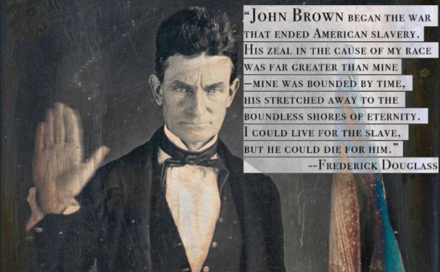
Part I:
Draw a t-chart and on one side (in bullet-point format) as you watch the documentary, note ways in which he acted as a “martyr for the slave”, willing to die for the cause of ending the institution of slavery. On the other side, note actions that could be cited to allege that he was also a “terrorist” and guilty of treason.
Part II:
After watching the documentary, write a response to Douglass’ statement in the image above in essay format. Please use the following questions as a guide when agreeing with or disputing the statement Douglass made.
- Discuss John Brown's zealotry. Explain the impact his childhood had on his own life and the way he raised his family. In what ways was he compassionate? Brutal? What were his goals for society? For his family? Did his ends justify his means? How does one account for his widely varying actions?

- Was John Brown's fight at Harpers Ferry the first step towards ending American slavery? Discuss the positive and negative aspects of the Harpers Ferry incident. Explain the immediate outcome of the trial. What outcome(s) occurred in the long run? Who benefited from Brown’s actions, and how? Who suffered from Brown’s actions, and how? Are lives lost in war worth the freedoms gained?

- Frederick Douglass remarked, "Did John Brown fail? John Brown began the war that ended American slavery." – analyze the extent to which this statement is true. Now that you’ve watched the documentary, to what extent do you believe him to be a martyr or a terrorist to the nation?

