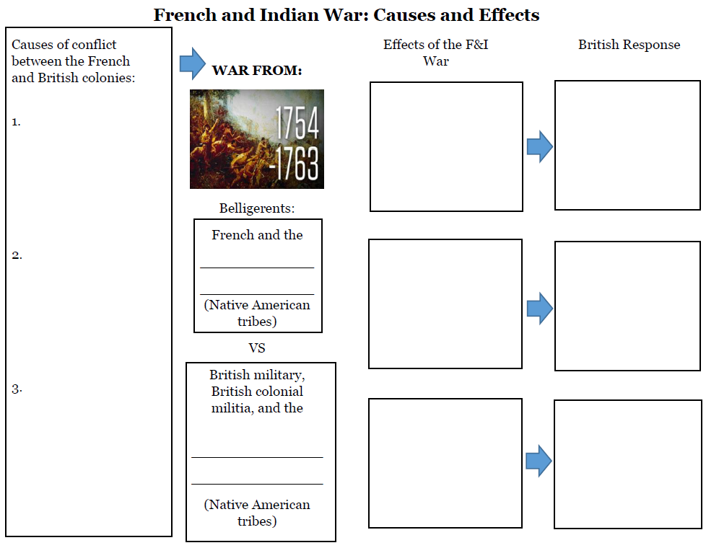

Insert tribes here

Insert tribes here