 | Monday | Tuesday | Wednesday | Thursday | Friday
Week One  Jan 25-Jan 26 |  |  |  | Start Quarter 3  Intro Day/  Begin  Unit 1 | Unit 2  1607-1754  Ch. 2-5  AMSCO 2-3
Week Two  Jan 29-Feb 2 | Unit 2  1607-1754  Ch. 2-5  AMSCO 2-3 | Unit 2  1607-1754  Ch. 2-5  AMSCO 2-3 | Unit 2  1607-1754  Ch. 2-5  AMSCO 2-3 | Unit 2  1607-1754  Ch. 2-5  AMSCO 2-3 | Unit 1-2  TEST
Week Three  Feb 5-9 | Unit 3  1754-1800  Ch. 6-10  AMSCO 4-6 | Unit 3  1754-1800  Ch. 6-10  AMSCO 4-6 | Unit 3  1754-1800  Ch. 6-10  AMSCO 4-6 | Unit 3  1754-1800  Ch. 6-10  AMSCO 4-6 | Unit 3  1754-1800  Ch. 6-10  AMSCO 4-6
Week Four  Feb 12-16 | Unit 3  1754-1800  Ch. 6-10  AMSCO 4-6 | Unit 3  1754-1800  Ch. 6-10  AMSCO 4-6 | Unit 3  TEST | Unit 4  1800-1848  Ch. 11-17  AMSCO 7-11 | Unit 4  1800-1848  Ch. 11-17  AMSCO 7-11
Week Five  Feb 19-Feb 23 | Presidents Day  No School | Teacher Workday  No School | Unit 4  1800-1848  Ch. 11-17  AMSCO 7-11 | Unit 4  1800-1848  Ch. 11-17  AMSCO 7-11 | Unit 4  1800-1848  Ch. 11-17  AMSCO 7-11
Week Six  Feb 26-Mar 1 | Unit 4  1800-1848  Ch. 11-17  AMSCO 7-11 | Unit 4  TEST | Unit 5  1844-1877  Ch. 18-22  AMSCO 12-15 | Unit 5  1844-1877  Ch. 18-22  AMSCO 12-15 | Unit 5  1844-1877  Ch. 18-22  AMSCO 12-15
Week Seven  Mar 4-8 | Unit 5  1844-1877  Ch. 18-22  AMSCO 12-15 | Teacher Workday No School | ACT Day for all Juniors | Unit 5  1844-1877  Ch. 18-22  AMSCO 12-15 | Unit 5  1844-1877  Ch. 18-22  AMSCO 12-15
Week Eight  Mar 11-15 | Teacher Workday  No School | Unit 5  1844-1877  Ch. 18-22  AMSCO 12-15 | Unit 5  TEST | Unit 6  1865-1898  Ch. 23-26  AMSCO 16-19 | Unit 6  1865-1898  Ch. 23-26  AMSCO 16-19
Week Nine  Mar 18-22 | Unit 6  1865-1898  Ch. 23-26  AMSCO 16-19 | Unit 6  1865-1898  Ch. 23-26  AMSCO 16-19 | Unit 6  1865-1898  Ch. 23-26  AMSCO 16-19 | Unit 6  1865-1898  Ch. 23-26  AMSCO 16-19 | Unit 6  1865-1898  Ch. 23-26  AMSCO 16-19
Week Ten  Mar 25-29 |  |  | Spring Break
Week One  Apr 1-5 | Unit 6  1865-1898  Ch. 23-26  AMSCO 16-19 | Unit 6  TEST | Unit 7  1890-1945  Ch. 27-35  AMSCO 20-25 | Unit 7  1890-1945  Ch. 27-35  AMSCO 20-25 | Unit 7  1890-1945  Ch. 27-35  AMSCO 20-25
Week Two  Apr 8-12 | Unit 7  1890-1945  Ch. 27-35  AMSCO 20-25 | End Quarter 3  Unit 7  1890-1945  Ch. 27-35  AMSCO 20-25 | Teacher Workday  NO SCHOOL | Start Quarter 4  Unit 7  1890-1945  Ch. 27-35  AMSCO 20-25 | Unit 7  1890-1945  Ch. 27-35  AMSCO 20-25
Week Three  Apr 15-19 | Unit 7  1890-1945  Ch. 27-35  AMSCO 20-25 | Unit 7  1890-1945  Ch. 27-35  AMSCO 20-25 | Unit 7  1890-1945  Ch. 27-35  AMSCO 20-25 | Unit 7  1890-1945  Ch. 27-35  AMSCO 20-25 | Unit 7  TEST
Week Four  Apr 22-26 | Unit 8  1945-1980  Ch. 36-39  AMSCO 26-29 | Unit 8  1945-1980  Ch. 36-39  AMSCO 26-29 | Unit 8  1945-1980  Ch. 36-39  AMSCO 26-29 | Unit 8  1945-1980  Ch. 36-39  AMSCO 26-29 | Unit 8  1945-1980  Ch. 36-39  AMSCO 26-29
Week Five  Apr 29-May 3 | Teacher Workday  NO SCHOOL | Unit 8  1945-1980  Ch. 36-39  AMSCO 26-29 | Unit 8  TEST | Unit 9  1980-Present  Ch. 40-42  AMSCO 30-31 | Unit 9  1980-Present  Ch. 40-42  AMSCO 30-31
Week Six  May 6-10 | Unit 9  1980-Present  Ch. 40-42  AMSCO 30-31 | Exam  Review | Exam  Review | Exam  Review | APUSH  Exam
Week Seven  May 13-17 | FLEX | FLEX | FLEX | FLEX | FLEX
Week Eight  May 20–24 | FLEX | FLEX | FLEX | FLEX | FLEX
Week Nine  May 27–31 | Memorial Day  No School | FLEX | FLEX | FLEX | FLEX
Week Ten  Jun 3-7 | FLEX | FLEX | FLEX | Exams | Exams
Week Eleven  June 10-14 | Exams | Exams | End Quarter 4  Exams | Teacher Workday  NO SCHOOL | Teacher Workday  NO SCHOOL
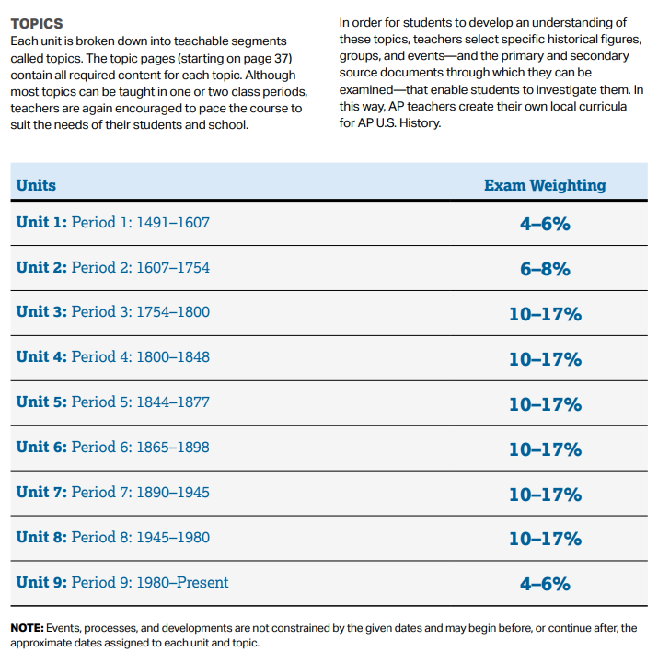
AMSCO = Preparing for the Advanced Placement Examination (Suggested review book; an AMSCO publication; more info on Day One PowerPoint)

The following is taken from https://apcentral.collegeboard.org/pdf/ap-us-history-course-and-exam-description.pdf?course=ap-united-states-history – it explains why certain periods receive more instructional days than others:

