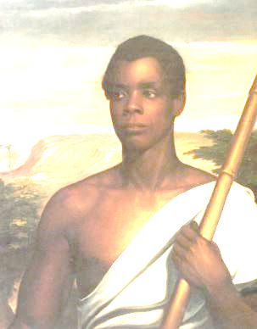
Amistad

1. What treaty is being referred to in the courthouse on the first day?
2. Theodore Joadson (Morgan Freeman) is the only main character that is also fictitious. As you watch, explain the purpose his character serves throughout the film.
3. It has been suggested that the character of Roger Baldwin (Matthew McConaughey) is portrayed as “everyman”, representing the audience’s prejudices and misconceptions. How does Baldwin change during the course of the film?
4. If the international slave trade was declared illegal in Britain, the United States, and the Spanish colonies before 1839, why did Spain want the Amistad Africans returned?
5. What are President Van Buren’s concerns about the Amistad case that John C. Calhoun’s correspondence brings to his attention? Whom is he trying to appease with the outcome of the trial and why?
6. In order for the Amistad Africans to receive their freedom, what had to be proven?
7. How is the problem of communication with the Africans resolved? How is this crucial to their cause?
8. What does Calhoun proclaim about the Southern economy compared to the North at this time? (Quote him during the film, so you can find the evidence that he is stating a truth at that time, or not.)
9. Why is the conversation between JQA and Cinque so poignant when Cinque talks about what he will do for strength during the trial?

Short Answer Reflection:

- Contrast the outcome of this case to other decisions/govt policies that contradict its more “progressive” nature. (Hint: address continuity and change over time.)

- There has been criticism that the filmmakers developed Amistad's black characters as essentially “foil characters” for the white characters’ self-discovery and moral growth. Argue the validity of this statement, citing evidence from the film.

